Influence of Cold Metal Transfer Process and Its Heat Input on Weld Bead Geometry and Porosity of Aluminum-Copper Alloy Welds
Cong Baoqiang¹, Ouyang Ruijie¹, Qi Bojin¹, Ding Jialuo²

¹ Beihang University, Beijing 100191, China; ² Welding Engineering and Laser Processing Centre, Cranfield University, Cranfield MK43 0AL, UK

Abstract: The weld bead geometry and the porosity of AA2219-T851 high strength aluminum alloy welds with ER2319 wire produced by different cold metal transfer (CMT) processes and heat inputs were investigated. The results show that a narrow finger-shaped geometry is observed using the conventional CMT process and a large number of gas pores exist in the lower and upper parts of welds. Compared to results of above mentioned CMT process, the weld melting area is increased using CMT-pulse (CMT-P) process, and it is beneficial to reduce the porosity effectively with an appropriate heat input. The finger-shaped geometry with lower melting depth using CMT-advanced (CMT-ADV) process and the spherical-shaped bead geometry with lower dilution using CMT-pulse advanced (CMT-PADV) process are achieved. The gas pore is reduced predominantly and even eliminated due to the lower heat input and the effective oxide cleanliness of wire ends for the two processes.

Key words: aluminum alloy; cold metal transfer; heat input; weld bead geometry; porosity

Cold metal transfer (CMT) process is a relatively novel welding technique which is characterized by its low heat input, no-spatter and high deposition rate^{[1]}. Recently CMT has been developed into different droplet transfer modes which are conventional CMT, CMT pulse (CMT-P), CMT advanced (CMT-ADV) and CMT pulse advanced (CMT-PADV). At present, CMT has been employed in the welding fabrication of Al alloy thin plates^{[2,3]}, Al/steel alloys^{[4]} and Al/Mg dissimilar alloys^{[5,6]}, etc. It has been observed that this process exhibits greater control of weld dilution which is beneficial in thin plates welding. In the actual welding fabrication of Al alloys, weld bead geometry as a significant impact and porosity as one of the most important defects, effectively affect and restrict the weld quality of Al alloys. However, in the previous research, few literatures have been published on the characteristics of weld bead geometry and porosity in Al alloy welds produced by these CMT processes. In the present paper, the aforementioned four different CMT processes with the variation of heat input were employed in the welding of Al-Cu alloy with ER2319 wire, their influences on the weld bead geometry and porosity were investigated, and the mechanism of porosity generation was also discussed, so as to provide a theoretical reference and practical experience for the welding fabrication of Al alloys and wire arc additive manufacturing (WAAM) of Al alloys with no porosity.
1 Experiment
The wrought AA2219 (temper T851) 19 mm thick plates with a chemical composition of Cu 6.3, Mn 0.3, Si 0.2, Fe 0.3, Zr 0.18 and Al balance (all in wt%) were used as substrates. ER2319 wire with 1.2 mm in diameter with a chemical composition of Cu 6.3, Mn 0.3, Zr 0.175, Ti 0.15, V 0.1 and Al balance (all in wt%) supplied by VBC group was used in its as-received condition. All the substrates were cleaned shortly before being used, by degreasing with acetone and linishing afterward.
In the present study, all the experiments were carried out in an open atmosphere with torch shielding only. Fronius CMT Advanced 4000 R was employed as the power source. A single-pass welding process was performed and single bead welds of 100 mm in length were obtained using the aforementioned four CMT processes. Arc current and voltage of these four different CMT processes are shown in Fig.1, and the wire feed speed (WFS) was 7.5 m/min. In order to control the variation of heat input (HI), constant WFS=7.5 m/min and variable welding speed (WS) were used and the parameter details are given in Table 1. HI for different trials were calculated using the formula HI=η()/WS^{[7]}, where and are arc voltage and current for each sample, respectively, and η is the arc thermal efficiency of CMT process that was set to 0.8^{[8,9]}. For all the trails, standard pure argon (99.99%) was used as shielding gas with a constant flow rate of 25 L/min, and the contact tip to work distance was kept to 15 mm.
The melting width B, melting depth H and weld reinforcement dH were used to describe the weld bead geometry as shown in Fig.2. The penetration R was calculated using the formula R=H/B×100%.
All samples were cut by a Discotom-60 automatic machining along the longitudinal and transverse directions. They were polished using a standard metallographic procedure, which consisted of grinding followed by polishing and etching. Specimens were etched with the standard Kroll’s reagent solution (6 mL HNO₃, 2 mL HF, 92 mL H₂O). Porosity and microstructure examinations were carried out using an OPTIPHOT optical microscope. Pore size and weld bead geometry were measured using the Axio Vision SE64 software.
2 Results and Discussion
2.1 Weld bead geometry
Fig.3 illustrates the correlations between the geometry and WS and Fig.4 shows the transverse sections of each sample. It is observed that, for the conventional CMT, CMT-P and CMT-ADV processes, B and dH are reduced with the increase of WS corresponding to the decrease of HI (Fig.3a and 3c). H is stabilized with higher HI as shown in Fig.3b, which denotes that H is about 2.2, 2.1 and 1.5 mm, respectively, correspon- ding to HI variation in 207.3~331.6 J/mm for CMT process, 305.7~366.8 J/mm for CMT-P process and 273.4~341.6 J/mm

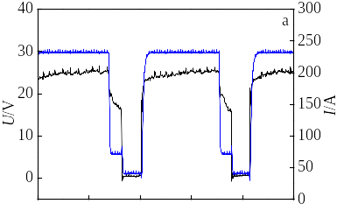
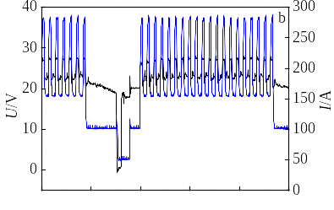
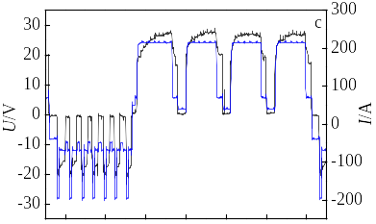
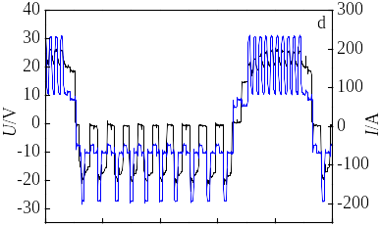
–
–
–
–
–
–
–
–
–
–
0 5 10 15 20 25
0 5 10 15 20 25
0 10 20 30 40 50
t/ms
0 10 20 30 40 50 60
t/ms

Fig.1 Arc voltage and current waveforms: (a) conventional CMT, (b) CMT-P, (c) CMT-ADV, and (d) CMT-PADV (WFS=7.5 m/min)

Table 1 Welding speed setting and the calculation of heat input
Serial  No. | CMT |  |  | CMT-P |  |  | CMT-ADV |  |  | CMT-PADV
Serial  No. | WS/m·min⁻¹ | HI/J·mm⁻¹ |  | WS/m·min⁻¹ | HI/J·mm⁻¹ |  | WS/m·min⁻¹ | HI/J·mm⁻¹ |  | WS/m·min⁻¹ | HI/J·mm⁻¹
1 | 1.0 | 165.8 |  | 1.0 | 183.4 |  | 0.8 | 170.8 |  | 0.5 | 135.4
2 | 0.8 | 207.3 |  | 0.8 | 229.3 |  | 0.6 | 227.8 |  | 0.4 | 169.3
3 | 0.6 | 276.3 |  | 0.6 | 305.7 |  | 0.5 | 273.4
4 | 0.5 | 331.6 |  | 0.5 | 366.8 |  | 0.4 | 341.6

dH
H
B

Fig.2 Schematic diagram of weld bead geometry
for CMT-ADV process. Compared to the CMT-P process, a narrow finger-shaped molten pool is developed during the conventional CMT process (Fig.4a), which means that with the similar B, although H is higher than that of CMT-P process, the melting area of weld is lower than that of CMT-P process, then the volume of molten pool is increased using the CMT-P process. Finger-shaped geometry with lower H and higher dH is obtained using the CMT-ADV process (Fig.4c). Different from above three processes, spherical-shaped weld bead is achieved with very low dilution using the CMT-PADV

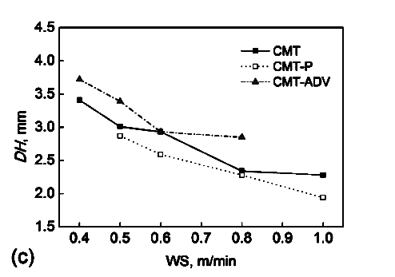
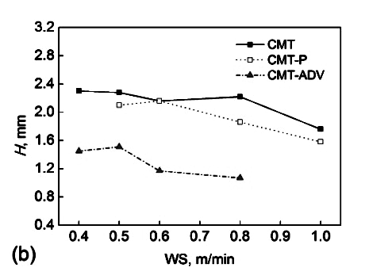
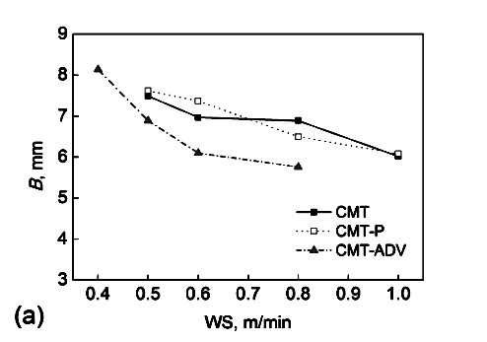
0.4 0.6 0.8 1.0
WS/m·min⁻¹
9
8
7
6
5
4
3

B/mm

0.4 0.6 0.8 1.0
WS/m·min⁻¹
CMT
CMT-P
CMT-ADV
0.4 0.6 0.8 1.0
WS/m·min⁻¹
a
CMT
CMT-P
CMT-ADV
3.2
2.4
1.6
0.8
H/mm

CMT
CMT-P
CMT-ADV
4.5
3.5
2.5
1.5

dH/mm

b
c

Fig.3 Correlations between: (a) B and WS; (b) H and WS; (c) dH and WS

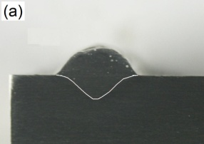
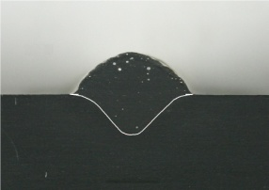
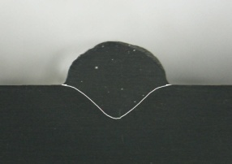
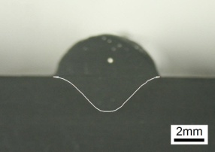
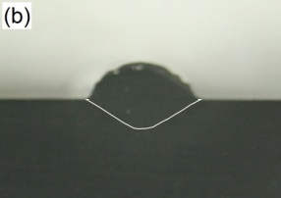
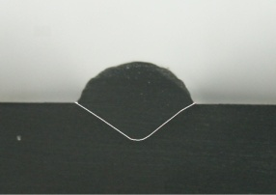
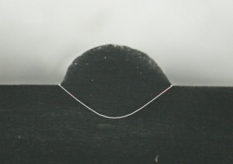
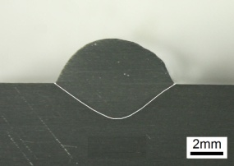
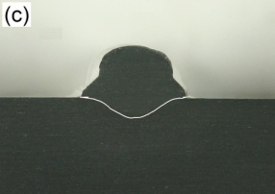
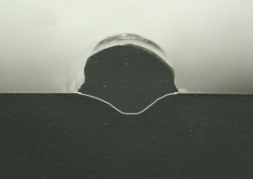
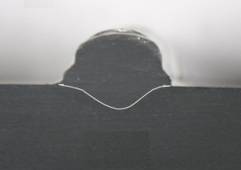
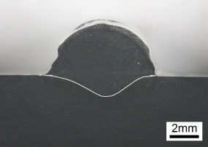
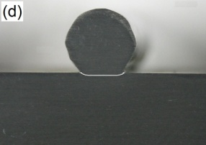
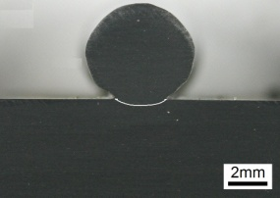
a
b
c
d
2 mm

Fig.4 Transverse sections of single-pass weld samples using different processes and heat inputs: (a) conventional CMT, WS=1.0~0.5 m/min, HI=165.8~331.6 J/mm; (b) CMT-P, WS=1.0~0.5 m/min, HI=183.4~366.8 J/mm; (c) CMT-ADV, WS=0.8~0.4 m/min, HI=170.8~341.6 J/mm; (d) CMT-PADV, WS=0.5~0.4 m/min, HI=135.4~169.3 J/mm (corresponding to WS decreasing from left to right)

process, as shown in Fig.4d. H is only about 0.4 mm with different WS of 0.5~0.4 m/min and HI of 135.4~169.3 J/mm.
It can be concluded that the weld bead geometry is significantly influenced by the heat input for these CMT processes. CMT-ADV and CMT-PADV are both the alternative welding processes, which means that there is more heat for melting filler wire and less heat for melting the base material during the process. In the case of constant WFS and WS, the heat input is obviously lower than that of the conventional CMT and CMT-P, which results in the significantly reduction of melting depth^{[10]}. Compared with the conventional CMT process, the CMT-P arc thermal power and the heat for the molten pool metal are significantly improved by the pulse current effect. The liquid metal has an enhancing flow from the pool edge to centre, which is affected by the pulsed arc force and the surface tension force, and then the melting area is increased. Conversely, a downward flow of liquid metal is weak so that the molten pool in the depth direction do not change obviously^{[11-13]}, so the weld finger-shaped geometry characteristics is not significant compared to that of the conventional CMT process.
2.2 Porosity distribution
Fig.5 illustrates the longitudinal distributions of gas pores using different CMT processes with different heat inputs. It can be clearly seen that the process and its heat input has a significant influence on the porosity. In all the samples, most of the gas pores are micro sized (10~50 µm in diameter). Compared to the other three processes, the conventional CMT process produces the highest amount of gas pores which are distributed in the lower and upper parts of the weld, and some gas pores are larger than 100 µm in diameter. The CMT-P process significantly reduces the number and the size of gas pores. An appropriate HI is beneficial to reduce the porosity (Fig.5b, WS=0.6 m/min, HI=305.7 J/mm). The CMT-ADV process further reduces the number and the size of gas pores with lower HI (Fig.5c, WS higher than 0.5 m/min, then HI lower than 273.4 J/mm). It is hard to find the gas pores with sizes larger than 50 µm in diameter. The porosity is nearly eliminated using the CMT-PADV process.

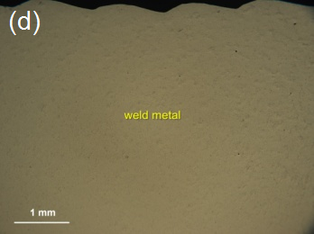
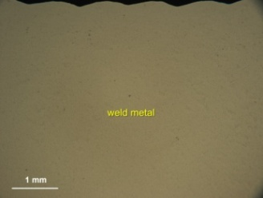
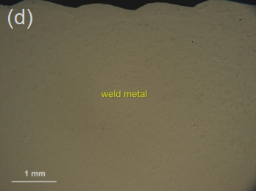
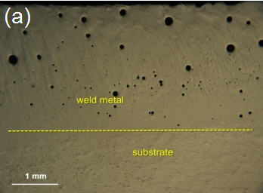
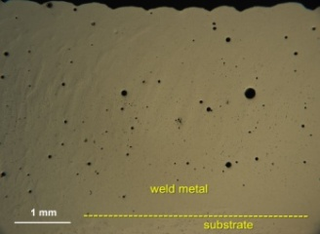
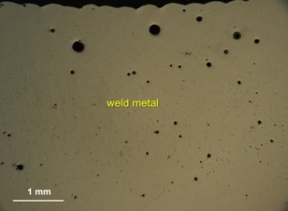
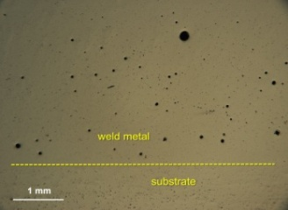
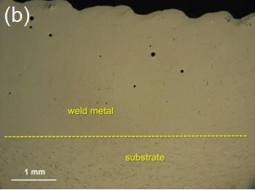
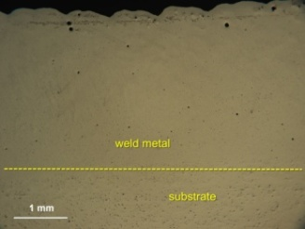
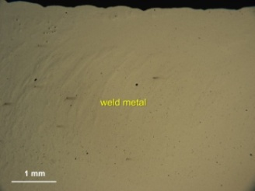
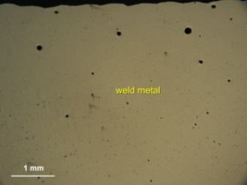
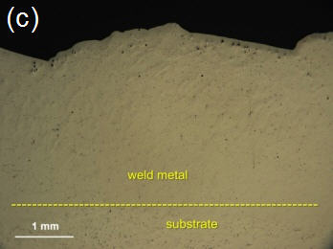
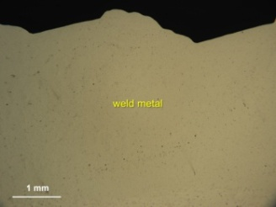
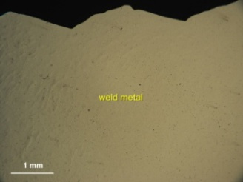
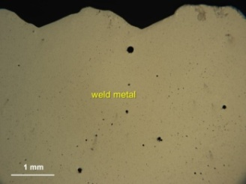
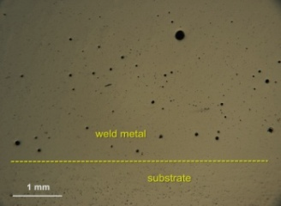
Weld metal
Weld metal
1 mm
d
Weld metal
Weld metal
Weld metal
Weld metal
Substrate
Weld metal
Substrate
Weld metal
Substrate
Weld metal
Weld metal
Weld metal
Substrate
Weld metal
Substrate
Weld metal
Weld metal
Substrate
c
b
a

Fig.5 Optical graphs showing porosity distribution in longitudinal direction: (a) conventional CMT, WS=1.0~0.5 m/min, HI=165.8~331.6 J/mm; (b) CMT-P, WS=1.0~0.5 m/min, HI=183.4~366.8 J/mm; (c) CMT-ADV, WS=0.8~0.4 m/min, HI=170.8~341.6 J/mm; (d) CMT-PADV, WS=0.5~0.4 m/min, HI=135.4~169.3 J/mm (corresponding to WS decreasing from left to right)

In order to reveal the mechanism of porosity generation in weld samples produced by these different CMT processes with different heat inputs, the weld bead geometry and microstructure were analyzed comprehensively. The ratio of B/(dH+H) indicating the slenderness of weld bead was also calculated as shown in Fig.6. The microstructures were analyzed in the longitudinal direction and some samples are shown in Fig.7.
The porosity formation in aluminum alloy is mainly due to the mutation of hydrogen solubility in the process of liquid to solid state transformation. According to the prior study^{[14-16]}, cellular dendrite, dendritic solidification interface and some inclusions can be used as heterogeneous nucleation particles and there is a competition correlation between dendrites growth and pore nucleation rate, and then the porosity has a close relationship with the grain size^{[17,18]}.
During the conventional CMT process, a narrow finger- shaped molten pool is developed which prevents the escapement of gas pores; meanwhile the coarse columnar grain structure increases the porosity formation (Fig.7a). Thus, a large number of pores can be observed in the samples made with the conventional CMT process. Although the HI of CMT-P process with the same WFS and WS is greater than that of the conventional CMT process, the porosity is still significantly reduced. It can be explained that the volume of molten pool is increased and the ratio of B/(dH+H) is higher as shown in Fig.6, which means that the chance of gas escapement is increased and the escapement distance is also less than that of the conventional CMT process with similar melting width as shown in Fig.3a. Meanwhile the fluidity of liquid metal in the molten pool is effectively enhanced due to the effect of pulse current which provides more chances of gas escapement.
The finger-shaped geometry with lower H and the mixture of finer columnar and equiaxed grain structures is observed using the CMT-ADV process (Fig.7c). Although the finger-shaped geometry is not beneficial in the gas escapement as explained for the conventional CMT process, much shallower penetrations are generated by the CMT-ADV process which significantly reduce its influence on the gas escapement. Compared with the CMT-P process, the grain structure is further refined due to a lower HI of CMT-ADV process. Meanwhile the arc with variable polarities in the CMT-ADV process can produce significant oxide cleanliness on the wire ends. This avoids the hydrogen content, which is usually contained in the oxidation layer, dissolving into the molten pool. In addition, the AC arc can also cause the molten pool stirring with the polarity converting in each cycle which is beneficial in the gas escapement^{[19]}. The lowest dilution and the finest equiaxed grain structure can be achieved using the CMT-PADV process (Fig.7d). This processes combines the advantages of the CMT-P and CMT-ADV processes which make it the most efficient process in terms of even eliminating the porosity.
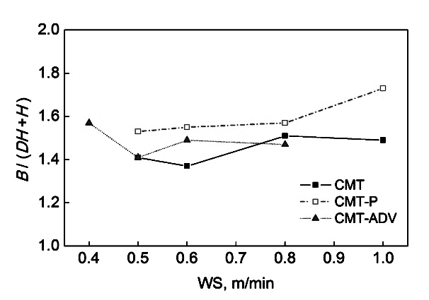
0.4 0.5 0.6 0.7 0.8 0.9 1.0
WS/m·min⁻¹
2.0
1.8
1.6
1.4
1.2
1.0
B/(dH+H)

CMT
CMT-P
CMT-ADV

Fig.6 Correlation between B/(dH+H) and WS

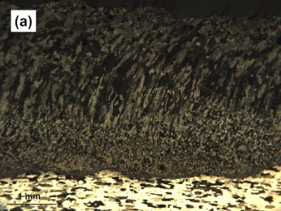
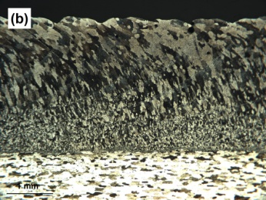
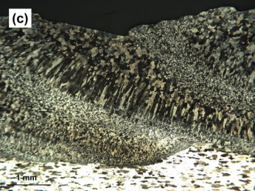
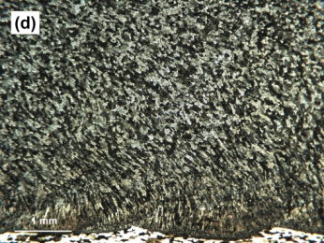
a
b
c
d
1 mm

Fig.7 Weld microstructure in longitudinal direction: (a) conven- tional CMT, WS=0.8 m/min, HI=207.3 J/mm; (b) CMT-P, WS=0.8 m/min, HI=229.3 J/mm; (c) CMT-ADV, WS=0.8 m/min, HI=170.8 J/mm; (d) CMT-PADV, WS=0.4 m/min, HI=169.3 J/mm
3 Conclusions
1) Weld bead geometry and porosity characteristics in AA2219-T851 alloy welds are significantly influenced by different CMT processes and their heat inputs. A narrow finger-shaped geometry is observed using the conventional CMT process. There are a large number of gas pores in the lower and upper parts of welds.
2) The weld melting area is effectively increased using the CMT-P process compared to that of conventional CMT process. It is beneficial to reduce the porosity effectively with an appropriate heat input, WFS=7.5 m/min, WS=0.6 m/min, and HI=305.7 J/mm： 容许偏差；答应偏差the ththe .

3) Finger-shaped geometry with the significant reduction of melting depth using CMT-ADV process is obtained. The gas pores are effectively reduced and even eliminated with lower heat input, WFS=7.5 m/min, WS higher than 0.5 m/min and HI lower than 273.4 J/mm.
4) Spherical-shape bead geometry with lower dilution using CMT-PADV process is achieved and the porosity is significantly eliminated.

References
- Pickin C G , Williams S W, Lunt M. Journal of Materials Processing Technology[J], 2011, 211: 496
- Feng Jicai, Zhang Hongtao, He Peng. Materials and Design[J], 2009, 30: 1850
- Pickin C G , Young K. Science and Technology of Welding and Joining[J], 2006, 11(5): 583
- Zhang Hongtao, Feng Jicai, He Peng et al. Materials Science and Engineering A[J], 2009, 499: 111
- Shang Jing, Wang Kelong, Zhou Qi et al. Materials and Design[J], 2012, 34: 559
- Cao R, Wen B F, Chen J H et al. Materials Science and Engineering A[J], 2013, 560: 256
- Cook G E, Eassa E H. IEEE Transactions on Industry Applications[J], 1985, 1A-21: 1294
- Pépe N, Egerland S, Colegrove P et al. Science and Technology of Welding and Joining[J], 2011, 16: 412
- Dupont J N, Marder A R. Welding Journal[J], 1995, 74(12): 406
- Harwig D D, Dierksheide J E, Yapp D et al. Welding Journal[J], 2006, 85(3): 52
- Lin M L, Eagar T W. Welding Journal[J], 1985, 64(6): 162
- Sun Junsheng, Wu Chuansong. Acta Metallurgica Sinica[J], 2001, 37(4): 434 (in Chinese)
- Sun Junsheng, Wu Chuansong. Science in China E Series[J], 2002, 32(4): 465 (in Chinese)
- Xing Junde. Special Casting and Nonferrous Alloys[J], 1993, 14(1): 30 (in Chinese)
- Shu Da, Sun Baode. Foundry Engineering[J], 1998, 22(1): 49 (in Chinese)
- Xu Lianghong, Tian Zhiling, Zhang Xiaomu et al. Transaction of the China Welding Institution[J], 2006, 27(12): 69 (in Chinese)
- Li Zhengyang, Zhu Mingfang, Dai Ting. Acta Metallurgica Sinica[J], 2013, 49(9): 1032 (in Chinese)
- Lee P D, Hunt J D. Acta Materialia[J], 2001, 49: 1383
- Kumar R, Dilthey U, Dwivedi D K et al. Materials and Design[J], 2009, 30: 306

CMT工艺及其热输入对Al-Cu合金焊缝成形和气孔的影响

从保强¹，欧阳瑞洁¹，齐铂金¹，丁佳洛²
(1. 北京航空航天大学，北京 100191)
(2. Welding Engineering and Laser Processing Centre, Cranfield University, Cranfield MK43 0AL, UK)

摘 要：采用4种冷金属过渡焊接工艺(CMT)分别在不同热输入水平下，使用ER2319焊丝进行AA2219-T851高强铝合金的平板堆焊成形，全面分析其焊缝成形和气孔分布特征。结果表明，常规CMT焊缝具有明显指状熔深特征，气孔缺陷严重并呈全焊缝分布状态； CMT-P焊缝母材熔化面积明显增大，气孔数量显著减少且在适当控制热输入时有助于消除气孔；CMT-ADV焊缝也具有指状熔深特征但熔深显著减小；CMT-PADV焊缝具有显著球形熔滴成形特征且熔深最小，两工艺低热输入和对焊丝表面氧化膜的清理作用有助于消除气孔。
关键词：铝合金；冷金属过渡；热输入；焊缝成形；气孔

作者简介：从保强，男，1979年生，博士，副教授，北京航空航天大学机械工程及自动化学院，北京 100191，电话：010-82339961，E-mail: congbq.buaa@gmail.com

