Effect of Different Substrate Temperatures on Microstru- cture and Residual Stress of Ti Films
Dong Meiling^{1,2}, Cui Xiufang¹, Wang Haidou², Zhu Lina³, Jin Guo¹, Xu Binshi²

¹ Harbin Engineering University, Harbin 150001, China; ² National Key Laboratory for Remanufacturing, Academy of Armored Forces Engineering, Beijing 100072, China; ³ China University of Geosciences, Beijing 100083, China

Abstract: The influence of different substrate temperatures of Ti film prepared by the direct current (DC) magnetron sputtering on the internal residual stress of Ti film were investigated experimentally by nanoindentation technique including Suresh model and Lee model. The results of the nanoindentation method and the curvature method were compared. At the same time, the surface morphology and the microstructure of Ti film were analyzed using atomic force microscope (AFM) and X-ray diffraction (XRD). The results show that the residual stress value obtained by Suresh model is almost the same as that by the curvature method, so the Suresh model is more suitable for calculating the residual stress of Ti films. Together with the nanoindentation data and micro-structure analysis, it is found that with the substrate temperature rising, the grain size of Ti films increases first and then decreases; the residual stress of the Ti film changes from the compressive stress to the tensile stress.

Key words: nanoindentation; curvature method; residual stress; film

With the development of optoelectronic technology, the applications of thin films to optics and electronic devices are found everywhere. However, residual stress exists in almost all films, due to the lattice mismatch or different thermal expansion coefficients between the film and the substrate ^{[1]}. The residual stress will impact the structure and the service performance of the film, and lead to crack formation and fatigue in the film or make the film become invalid under the circumstances, which greatly shortens the service life of the product ^{[2]}. Titanium and its alloys are important materials in the fields of modern life science, military and aerospace. They have high strength and favorable corrosion resistance performance, as well as the advantages of nice biological compatibility ^{[3]}. Therefore, it is very important to research the residual stress in DC magnetron sputtering Ti film.
Currently, many researchers have measured the residual stresses of thin films employing different methods such as X-ray diffraction method, curvature method and Raman spectroscopy technique. X-ray diffraction method is only applied to measure the lattice semiconductor or crystal film, and has certain requirements on the film thickness ^{[4]}. Raman spectroscopy technique is often used to measure the residual stress of MEMS (micro-electro-mechanical system) devices, but this method is some restricted by fluorescence interference and low detection sensitivity ^{[5, 6]}. Curvature method has characteristics of convenience and high accuracy which can obtain the average residual stress without destroying samples. It’s widely used in the measurement of thin film residual stress, but this method has a high requirement of the roughness on the surface of the sample. In place of these methods, the present study focuses on a technique to evaluate residual stress using an indentation method.
Residual stress measurement by the nanoindentation technique has been considered a promising process. Nanoindentation is a method which uses the displacement and the strain that result from the partial load to infer the residual stress of the material. In the present paper, the residual stresses in the Ti films at different substrate temperatures were investigated by nanoindentation. The residual stresses were calculated based on the theoretical models of Suresh et al. ^{[7]} and Lee et al. ^{[8]}. By comparing with the results of curvature method, the error sources were analyzed.

1 Theory of Two Residual Stress Measurement Methods
1.1 Theory of nanoindentation
At present, nanoindentation techniques are widely used for measuring the mechanical properties of both solids and thin films, and allow the measurement of residual stress at nanoscale ^{[9]}. Several methodologies have been developed for the determination of the residual stresses from the indentation P-h (load-depth) curves. Suresh model and Lee model determined biaxial residual stresses using sharp indentation Swadener model ^{[10]} based on spherical indentation. The contact pressure at initial yielding was proposed as a stress indicator via analyzing the elastic deformation beneath the spherical indenter. Recently, with the application of finite element simulations, Xu and Li et al ^{[11, 12]} have systematically investigated the influence of residual stress on the elastic recovery of nanoindentation. Suresh model and Lee model are widely used amongst them. Although the principles of measurement are not identical, Lee model and Suresh model are applicable to biaxial residual stress state. In the present article, the residual stress was calculated by the model of Suresh and Lee to determine which one was more suitable for measuring the residual stress of Ti films.
In 1998, a theoretical model using a geometrically similar sharp indenter was proposed by Suresh and Giannakopoulos ^{[7]} to characterize the equi-biaxial thin-film stress. In this model, the residual stress in the film is determined based on the indentation contact area difference between a residual stress-free material and the same material with residual stress. The residual stress σ^{R} can be calculated by the following equations.
For tensile residual stress:
(1)
For compressive residual stress:
(2)
where H is the hardness of the material. sinα is a geometric factor, where α is related to the indentation angle of the indenter. For a Berkovich indenter, α=24.7° and sinα= 0.418. A and A₀ are the projected contact areas for materials with and without residual stress σ^{R}, respectively.
In 2004, Lee and Kwon ^{[8]} developed a new method to estimate two-dimension residual stress based on the analysis of the stress relaxation during the depth-controlled indentation. The model can measure the residual surface stress in the equi-biaxial and uniaxial states. Two major stresses are σ_{x} and σ_{y} (σ_{y} = k σ_{x}), and σ_{x} can be calculated by the following equation:
(3)
where P and P₀ are the maximum loads for the materials with and without residual stresses, respectively. A₁ is the projected contact area for the material with stress state. For the state of equi-biaxial residual stress, k =1^{[13]}.
1.2 Theory of curvature method
Curvature method is suitable for calculation of two-dimensional stress state, which has the same premise as nanoindentation models. It is assumed that isotropic biaxial stress exists in the film which is at the same temperature. Substrate will bend slightly when the two-dimensional residual stress appears after the film is formed. The residual stress is determined by measuring the change of the substrate curvature before and after film deposition. The parallel monochromatic light is used by electronic film stress distribution tester to form the interference between the surfaces of flat plane and film. The residual stress is determined by measuring the change of the interference fringe before and after film deposition. The residual stress can be calculated by the Stoney equation ^{[14]}:
(4)
−
where σ is residual stress in the film, t_{s} and t_{f} are the thicknesses of the substrate and thin film, respectively. E_{s} and ν_{s} are the young's modulus and Poisson's ratio of substrate, respectively. R₁ and R₂ are the curvatures of the substrates before and after the film deposition, respectively. This method requires the shapes of the substrate be circular or rectangular ^{[15]}.

2 Experiment
2.1 Specimen preparation
An isotropic Ti film was deposited on (100) single side polished Si wafers with diameter of 50 mm in order to exclude the additive effects of microstructure and anisotropic deformation on the nanoindentation curve. The films were made by the AS500DMTXB automatic computer- control ion evaporator. The purity of Ti target was 99.99%. The substrate was dipped into acetone and cleaned with ultrasonic washer for 15 min, and then it was dried in vacuum for deposition. The substrate was cleaned for 3 min by argon with the washing flow of 200 cm³/min and bias voltage of 100 V. The reaction vacuum degree and power were 0.88 Pa and 0.5 kW, respectively. Ti thin films with 1.3 μm in thickness was deposited onto Si substrates at 200, 300, 400 and 460 ºC.
2.2 Microstructural characterization
The prepared Ti thin film samples were characterized in various ways. OLS400 three-dimensional laser electron microscope was used to measure the thickness. Its precision can reach 0.5 μm which meets the demand of the experiment. Surface morphology and average surface roughness were measured by scanning electron microscopy (SEM) and atomic force microscope (AFM), respectively. Composition was analyzed by D8 X-ray diffraction. Nanoindentation tests were performed using NanoIndenter G200 with a Berkovich indenter. In order to avoid substrate effect, the maximum indentation depth was 100 nm. BGS 6341 electronic film stress distribution tester was used to measure the distribution of stress in the film to compare with nanoindentation results.
3 Results and Discussion
3.1 Effect of substrate temperature on surface mor- phology and grain size of Ti film
Fig.1 shows SEM images of Ti film deposited on the substrate with 300 °C. It is seen that the surface morphology of the film is relatively dense and smooth. The film exhibits a regular cellular shape.
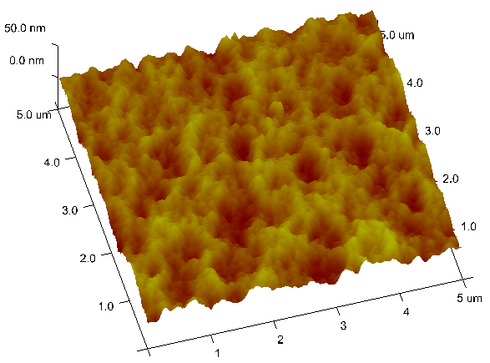
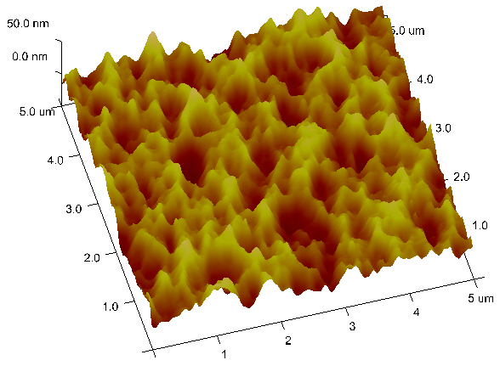
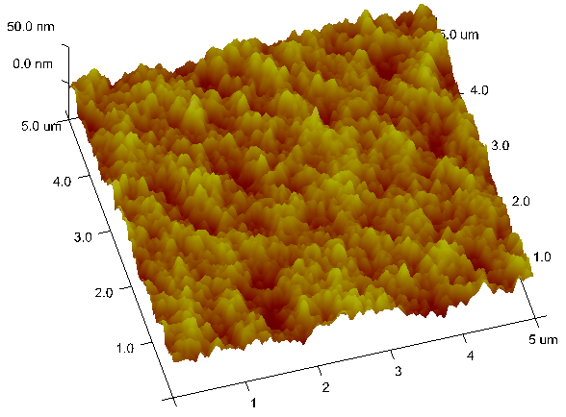
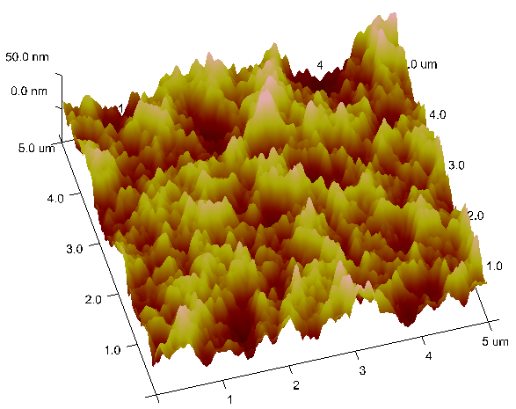
Fig.2 shows the three-dimension AFM images of Ti films deposited at different substrate temperatures. The surface morphology and the roughness of Ti film are different at different substrate temperatures. From the images we can see when the substrate temperature reaches 200 °C, the density of the film increases with temperature elevating, and grains grow gradually and the size difference between the grains increases. Grains are refined and uniform when the substrate temperature is higher than 400 °C. Smooth film with closely packed grains is obtained when the substrate temperature reaches 460 °C. In addition, with the increase of the substrate temperature, the surface roughness of the thin film increases from R_{a} = 4.94 nm (at 200 °C) to R_{a} = 8.25 nm (at 300 °C). However, the roughness decreases from 13 nm to 5.75 nm, when the substrate temperature is between 400 and 460 °C. It is obvious that the roughness of Ti film first increases with the substrate temperature increasing and then decreases. It can be concluded that the changes of surface roughness are similar to that of grain size. According to the change of the surface morphology and the roughness at different substrate temperatures and the diffusion theories of thin film growth ^{[16]}, it is found that the surface of Ti film consists of isotropic coronary islands at 200 °C, and larger cavities appear in some positions. As the motor energy of sputtered particles on the surface of thin film is small, the ability of diffusion is bad, and thus
.0 µm
5.0 µm
5.0 µm
5.0 µm
5.0 µm
a
b
c
d
0000000
0000000
0000000
0000000
0000000
0000000
0000000
0000000
0000000
0000000
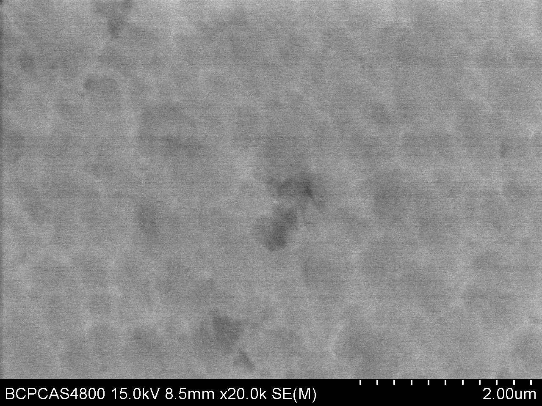

1 μm

Fig.1 SEM image of Ti film deposited on the substrate with 300 °C

Fig.2 Surface morphologies of Ti film deposited at different substrate temperatures: (a) 200 °C, (b) 300 °C, (c) 400 °C, and (d) 460 °C

the particles exhibit a three-dimensional island growth model. The sizes of grains begin to grow up around 300 °C. When the substrate temperature is above 400 °C, titanium atoms can fully react with each other, and the ability of diffusion of atoms in the film is enhanced. Therefore, the islands are connected gradually, then the quantity of cavities is decreased, and the film is getting more and more compact. The grains are getting finer, and the channel of film is fully filled to eventually form the continuous film through the growth of film, resulting in forming of the new island phase in the channel. It can be considered that the magnetron sputtering Ti films grow mainly through diffusion according to the island growth pattern.
3.2 Influence of substrate temperature on composition and crystal orientation of Ti film
XRD patterns for Ti films at different substrate temperatures are shown in Fig.3. The results show that the Ti sputtered film has hexagonal closed-packed (hcp) structure. The three strong peaks of (110), (002) and (101) mainly appear in the Ti films at different substrate temperatures. Ti films prepared at four substrate temperatures all have the characteristics of orientation growth of (002) with the least free energy. As the temperature increases, the peaks become more acute. Due to the influence of the substrate, strong diffraction peaks exist on the (110) direction. With the increase of temperature, the intensity of the diffraction peak becomes weaker. When the temperature reaches 460 °C, (110) diffraction peak almost disappears; (100) and (101) diffraction peaks with small free energy appear afterwards and are strengthened gradually. It is shown that with the increase of temperature, the peak tends to appear at the low angle. At 460 °C, the strongest peak is changed to (101) crystal plane with small strain energy. This shift basically meets the energy minimization theory of film ^{[17]}.
3.3 Influence of substrate temperature on residual stress of Ti film
3.3.1 Results of curvature method
The residual stresses measured by the curvature method are shown in Table 1. It shows that the residual stress changes from the compressive stress to tensile stress, and then the tensile stress increases gradually with the substrate temperature increasing. The distribution of residual stress in Fig.4 is obtained from Table 1.
Fig.4 and Fig.5 show the distribution of residual stress measured by electronic film stress distribution tester. There is no obvious distribution law of residual stress in the films, and the distribution is uneven. The smooth degree of the substrate before deposition is responsible for it. However, the overall trend is that the higher the temperature of the substrate, the more heterogeneous the distribution of the residual stress. When the substrate is at the temperature of 300 °C, the internal residual stress of the film is the

Fig.3 XRD patterns for Ti films at deposited different substrate
temperatures

Table 1 Distribution of residual stress for Ti films at different substrate temperatures using curvature method
T/°C | σ_{avg}/GPa | σ_{min}/GPa | σ_{max}/GPa
200 | -1.026 | -1.576 | -0.611
300 | 0.344 | -0.174 | 0.624
400 | 0.522 | -0.746 | 1.953
460 | 0.635 | -0.938 | 2.180

Fig.4 Distribution of residual stress for Ti films deposited at different substrate temperatures

minimum, the residual stress range is the smallest and the distribution is the most homogeneous.
3.3.2 Measurement of residual stress by nanoindentation
Fig.6 shows load-depth curves of the stressed and stress -free Ti films deposited at different substrate temperatures and at a maximum depth of 100 nm. In the present study, the stress-free sample was obtained by removing the NaCl substrate with deionized water, and the stress was released completely. It is can be seen from Fig.6, the position with tensile stress requires smaller load to indent the same depth than the stress-free position and the elastic recovery is smaller. With the increase of temperature, the residual stress of Ti film changes from compressive stress (at 200 °C) to tensile stress gradually. It is concluded that the residual stress in Ti film is compressive, because the surface stress can restrain the crystallization of micro crystals at the initial growth stage of thin film which is composed of many independent micro crystals. With the increase of temperature, the micro crystals grow up gradually, and the distances between them become smaller. Stress increases and tensile stress is generated. It is revealed that the higher the substrate temperature, the higher the tensile residual stress. With the increase of substrate temperature, gains grow up, tensile residual stress is generated. When the substrate temperature increases gradually, vacancies disappear. Due to the refinement of gains, the volume is shrank and the surface of film become homogeneous and dense, then the tensile residual stress is increased ^{[18]}.
The residual stress results of the different methods are shown in Table 2. In the present paper, it is assumed that biaxial stress exists in the film. For Lee model k=1. Suresh model and Lee model were used to calculate the residual stress in Ti film. Comparing the results of two models, it is found that the value calculated by Lee model is greater than that by Suresh model. When compressive stress exists, small deviation exists between the results of Lee model and

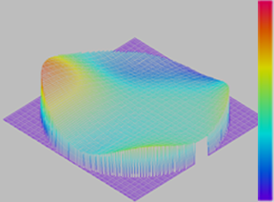
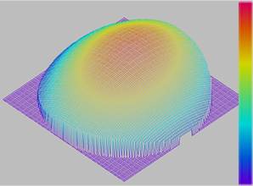
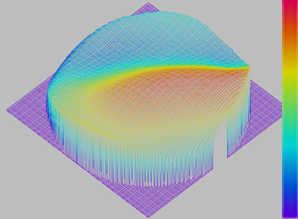
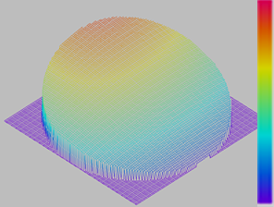
a
b
c
d

Fig.5 Three-dimensional distribution of residual stress for Ti films deposited at 200 °C (a), 300 °C (b), 400 °C (c), and 460 °C (d)

Fig.6 Typical load-depth curves for Ti films deposited at 200 °C (a), 300 °C (b), 400 °C (c), and 460 °C (d)

Table 2 Residual stress results of different methods (GPa)
Temperature/°C | σ-Curvature method | σ-Suresh  model | σ-Lee  model
200 | -1.026 | -0.909 | 0.615
300 | 0.344 | 0.336 | 2.158
400 | 0.522 | 0.517 | 2.887
460 | 0.835 | 0.814 | 3.644
curvature method; when tensile stress exists, the difference becomes obvious. The residual stresses obtained by Suresh model and curvature method are close, and error is less. It is concluded that the measurement of residual stress in the film using nanoindentation technology is feasible, and Suresh model is more suitable for measuring the internal residual stress of Ti film.
In the present study, there is certain difference between the results of nanoindentation technology and curvature method. The residual stress is determined by curvature method through measuring the macro-displacement of the material, which is related to the surface roughness and the uniformity of substrate. Compared with the real residual stress of the film, certain error exists. However, the application of the Suresh and Lee methods in determination of residual stress requires a stress-free reference sample, which is often very difficult to be obtained. In addition, the problem of pile-up deformation around indents is not taken into account, leading to certain errors.

4 Conclusions
1) Ti films with smooth surface and dense structure can be deposited by the magnetron sputtering method. The substrate temperature has significant effects on the surface morphology and the growth orientation of Ti film. With the increase of the substrate temperature, the size of grains increases first and then decreases. When the temperature reaches a certain level, crystal orientation moves to the lower angle location.
2) The residual stress in Ti films can be measured by nanoindentation method and curvature method. The trends of the results are similar, and nanoindentation method is suitable for measuring the residual stress of Ti film. Compared with curvature method, the results of Suresh model are closer than those of Lee model and thus the Suresh model is more suitable for calculating residual stress of Ti films.
3) The residual stress calculated by Suresh model varies in the range of 1.026 ~ 0.835 GPa. The residual stress changes from the compressive stress to tensile stress, and then the tensile stress increases gradually with the substrate temperature increasing. The residual stress of Ti films at 300 °C is the minimum and most uniform.

References
- Cammarata R C. Journal of Electronic Materials[J], 1997, 26(9): 966
- Jiang L M, Peng J, Liao Y G et al. Thin Solid Films[J], 2011, 519: 3249
- Li Li, Wei Wu, Jin Yongzhong et al. Journal of Xihua University, Nature Science[J], 2009, 28(2): 92 (in Chinese)
- Wang Cheng, Zhang Guiyan, Ma Ying. Laser and Electronics [J], 2004, 41(9): 28
- Starman L, Coutu R. Exper Mechanics[J], 2012, 52: 1341
- Wang Haidou, Zhu Lina. Xing Zhiguo. Residual Stress Testing Technology[M]. Beijing: China Machine Press, 2013: 31 (in Chinese)
- Suresh S, Giannakopoulos A E. Acta Materialia[J], 1998, 46: 5755
- Lee Y H, Kwon D. Acta Materialia[J], 2004, 52: 1555
- Fjodor Sergejev, Eduard Kimmari, Mart Viljus. Physics Engineering[J], 2011(10): 2873
- Swadener J G, Taljat B, Pharr G M. Materials Research Society Symposium[J], 2000, 594: 519
- Xu Zhihui, Li Xiaodong. Micro and Nano Mechanical Testing of Materials and Devices[J], 2008(1): 139
- Pitarresi J M, Manolis G D. Computers and Structures[J], 1991, 41(4): 647
- Khan M K, Fitzpatrick M E, Hainsworth S V. Computational Materials Science[J], 2011, 50: 2967
- Stoney G G. Proc Roy Soc London[J], 1909, 82: 169
- Flinn P A, Gardner D S, Nix W D. IEEE Trans Electron Dev [J], 1987(4): 689
- Hu Qinggeng, Xun Cai, Hua Rongyong. Fundamentals of Science[M]. Shanghai: Shanghai Jiaotong University Press, 2000: 131 (in Chinese)
- Mckenzie D R, Yin Y, Mcfall. Phys: Condense Matter[J], 1996, 8(32): 5883
- She Hui, Wang Biao. Basic Research[J], 2008, 5(3): 4

不同基底温度对Ti薄膜表面形貌及残余应力的影响

董美伶^{1,2}，崔秀芳¹，王海斗²，朱丽娜³，金 国¹，徐滨士²
(1. 哈尔滨工程大学，黑龙江 哈尔滨150001）
(2. 装甲兵工程学院 装备再制造技术国防科技重点实验室，北京 100072）
(3. 中国地质大学 (北京), 北京 100083）

摘 要：采用纳米压痕法中的Suresh 模型和Lee模型研究不同基底温度对直流磁控溅射制备的Ti薄膜中残余应力大小及分布的影响。将压痕法计算结果与曲率法结果进行比较研究，同时采用原子力显微镜和X射线衍射仪对Ti薄膜的表面形貌及相结构进行分析。结果表明：Suresh 模型计算得到的Ti薄膜残余应力值与曲率法结果最为接近，因此Suresh 模型更适合测量Ti薄膜中的残余应力。结合纳米压痕和显微结构的分析发现，随着Ti薄膜基底温度的升高，Ti薄膜的晶粒尺寸先增大后变小，残余应力则从压应力转变为拉应力。
关键词：纳米压痕；曲率法；残余应力；薄膜

作者简介：董美伶，女，1989年生，硕士生，哈尔滨工程大学表界面科学与技术研究所，材料科学与化学工程学院，黑龙江 哈尔滨150001, E-mail: 929969599@qq.com

