Theoretical Calculations on Electronic Structure and Optical Properties of Orthorhombic SrHfO₃ in Cmcm Space Group
Tian Hao, Feng Liping, Liu Zhengtang

State Key Laboratory of Solidification Processing, Northwestern Polytechnical University, Xi’an 710072, China

Abstract: Electronic structure and optical properties of Cmcm orthorhombic SrHfO₃ were computed, using the plane-wave ultrasoft pseudopotential technique based on the first-principles density functional theory (DFT). The equilibrium lattice parameters of orthorhombic SrHfO₃ are in good agreement with experimental values. The band structure, the densities of states (DOS) and charge densities of Cmcm orthorhombic SrHfO₃ have been obtained. The band structure shows that Cmcm orthorhombic SrHfO₃ has direct band gap. The charge densities of Cmcm orthorhombic SrHfO₃ indicate that bonding between Hf and O is mainly covalent whereas the bonding between Sr and O is mainly ionic. The complex dielectric function, refractive index and absorption coefficient of Cmcm orthorhombic SrHfO₃ have been predicted. The imaginary and real parts of the calculated complex dielectric function are close to the results of experimental measurements.

Key words: first-principles; electronic structure; optical properties; orthorhombic SrHfO₃ material

Recently, ABO₃ perovskite materials are extensively studied due to their unusual ferroelectric, piezoelectric, dielectric, magnetic and electrochemical properties ^{[1-11]}, which have many technological applications in the thermal barrier coatings ^{[4,5]}, microwave ceramic resonators ^{[6]}, optoelectronic materials ^{[7,8]}, phosphor ^{[9]}, and high-κ dielectric gate in MOSFET ^{[10,11]}, etc. Among them, Hf-based SrHfO₃ perovskite oxide has attracted much attention because of its good electrical and physical properties such as high dielectric constant, large band gap, optimal band offsets and high melting temperature. Additionally, SrHfO₃ used as high-gate dielectric oxides for the next generation of CMOS devices have been studied both experimentally ^{[11-13]} and theoretically ^{[14-16]}. Previous theoretical studies focused mainly on the high temperature cubic phase of SrHfO₃ ^{[15-19]}. Nevertheless, SrHfO₃ adopts the Cmcm orthorhombic structure in a wide range of temperatures where its useful applications take place. However, there are very few theoretical studies on the properties of orthorhombic SrHfO₃^{[20, 21]}. In order to fully take advantage of the properties of SrHfO₃ in applications of optoelectronic devices, the theoretical investigations of the electronic structure and the optical properties of orthorhombic SrHfO₃ are crucial. To the best of our knowledge, no systematical studies on the relations between electronic structure and optical properties of orthorhombic SrHfO₃ have been reported so far.
In the present paper, the first-principles calculations were used to study the electronic structure and the optical properties of Cmcm orthorhombic SrHfO₃. Current work was focused on investigating the relations between electronic structure and optical properties of Cmcm orthorhombic SrHfO₃ so as to clarify its mechanism of optical transitions.

1 Computation Methods
The calculations presented in this study were performed using the localized density approximation (LDA) with the Ceperley-Alder-Perdew-Zunger (CA-PZ) function ^{[22]} based on density functional theory (DFT) and implanted in CASTEP package ^{[23]}. The ionic cores were represented by ultrasoft pseudo-potentials for Hf, Sr and O atoms. The Sr 4s, 4p, 5s electrons, Hf 5p, 5d, 6s electrons and O 2s, 2p electrons were explicitly treated as valence electrons. The plane-wave cutoff energy was set to be 380 eV and the Brillouin-zone integration was performed over the 4×4×3 grid sizes using the Monkorst-Pack method ^{[24]} for structure optimization. This set of parameters assured the total energy convergence of 5.0×10⁻⁶ eV/atom, the maximum force of 0.1 eV/nm, the maximum stress of 0.02 GPa, and the maximum displacement of 5.0×10³ nm.

2 Results and Discussion
2.1 Structure optimization
Orthorhombic SrHfO₃ in Cmcm space group has the local symmetry of D_{2h}¹⁷. The total energy of Cmcm orthorhombic SrHfO₃ was calculated at different volumes around the experimental volume. The calculated total energies were fitted to the Murnaghan^{[25]} equation of state to obtain the equilibrium lattice constant. Fig.1 shows the energy-volume curves. In Fig.1, the lowest energy comes from the volume of 71.4×10⁻³nm³ and then the equilibrium lattice parameters of Cmcm orthorhombic SrHfO₃ can be obtained. Table 1 summarizes the calculated lattice constants of Cmcm orthorhombic SrHfO₃ as compared with other theoretical values ^{[5, 11, 17, 19]} and experimental data ^{[10, 12, 21]}. It can be seen that our calculated results are in good agreement with the available experimental values ^{[10, 12]}.
2.2 Electronic structure
The energy band structure of orthorhombic SrHfO₃ in Cmcm space group is shown in Fig.2. The Fermi level (E_{F}) is set to zero energy. It can be seen from Fig.2 that orthorhombic SrHfO₃ in Cmcm space group has direct band gap because the top valence and the bottom conduction are

Fig.1 Calculated total energies as a function of the cell volumes for Cmcm orthorhombic SrHfO₃
found at the same G point. The calculated band gap of Cmcm orthorhombic SrHfO₃ is about 3.25 eV, which is in agreement with other calculational results (3.74 eV ^{[14]}, 3.7 eV ^{[18]} and 3.2 eV ^{[19]}). Nevertheless, the calculated band gap is smaller than the experimental data of 6.1 eV ^{[11]} because of the well-known underestimation of conduction band state energies inabinitio calculations.
Fig.3 shows the total and the partial DOS of Cmcm orthorhombic SrHfO₃. As can be seen, there are three valence bands in the total DOS of Cmcm orthorhombic SrHfO₃. The lower valence bands from –32.7 eV to −31.7 eV are composed of Sr-s states. The middle valence bands from −17.1 eV to −13.1 eV are essentially dominated by Sr 4p and O 2s. The upper valence bands from −4.0 eV to −0.3 eV consist mainly of O 2p which shows a hybridization character with Hf 5d electrons. In addition, the unoccupied conduction bands from 4.2 eV to 10 eV are composed predominantly of Hf 5d which shows a hybridization character with O 2p and Sr 4p. Moreover, the s state of Sr atom and s, p states of Hf atom are also contributing to the conduction bands, but the values of densities of these states are quite small compared with Hf 5d states.
Fig.4 shows the charge densities in the (020) plane of Cmcm orthorhombic SrHfO₃. It is clear to see from Fig.4 that the bonding structure between Sr and O is mainly ionic for Cmcm orthorhombic SrHfO₃. Additionally, the bonding structure between Hf and O is mainly covalent due to Hf 5d and O 2p hybridization. These characteristics agree well with the results of previous analysis of DOS.

Table 1 Calculated lattice constants (a, b and c) of Cmcm orthorhombic SrHfO₃ as compared with the other calculational values and experimental data (nm)
Constants | a | b | c
This work | 0.821 24 | 0.832 35 | 0.831 07
Previous Calc.^{[11]} | 0.804 99 | 0.807 28 | 0.805 54
Expt. ^{[12]} | 0.817 41(16) | 0.819 74(12) | 0.817 97(11)

Fig.2 Band structure of Cmcm orthorhombic SrHfO₃ along with the high-symmetry points of the Brillouin zone

Fig.3 Total and partial densities of states of Cmcm orthorhombic SrHfO₃

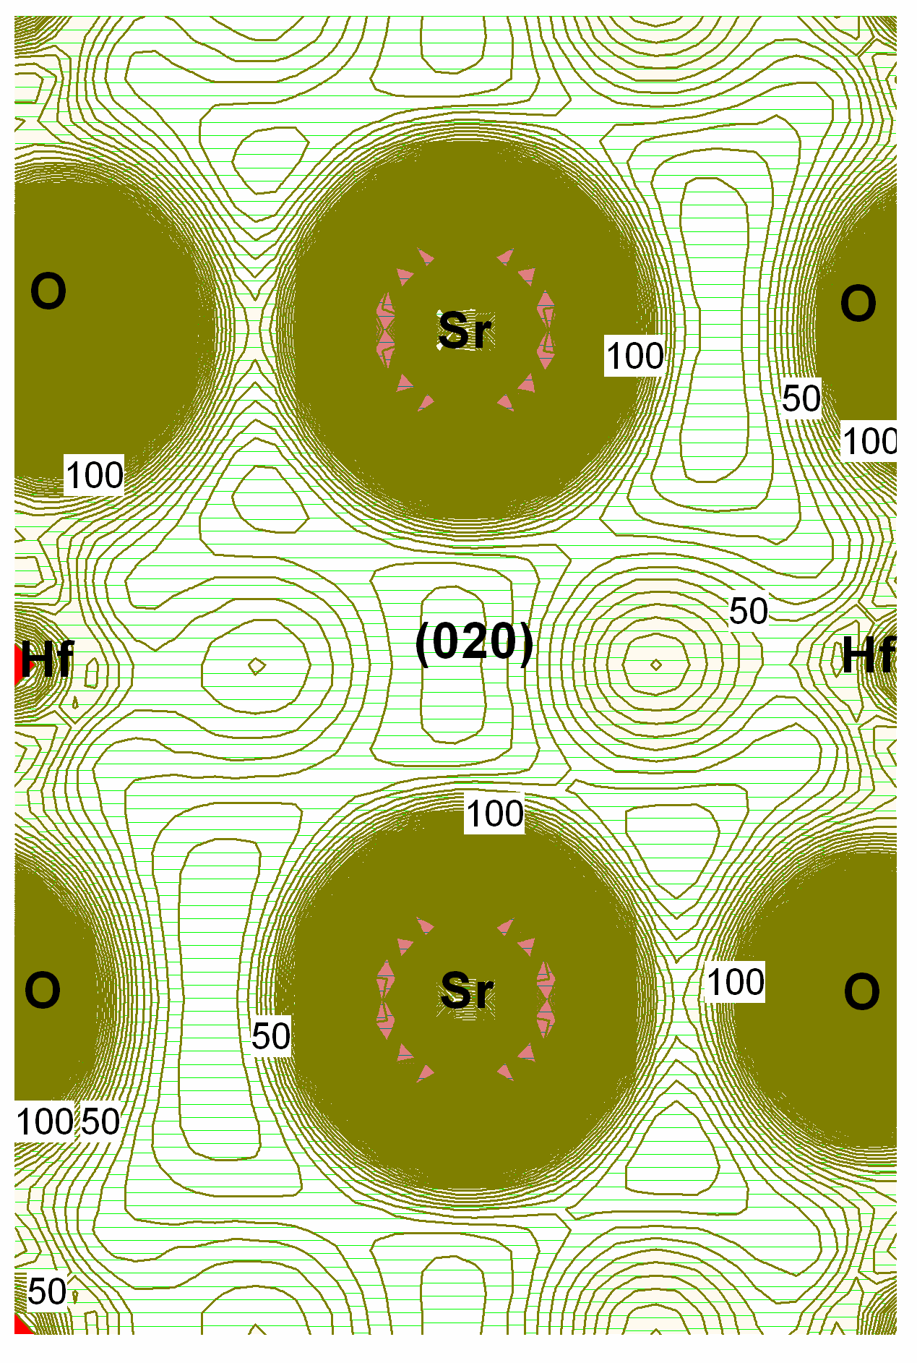

Fig.4 Charge densities of Cmcm orthorhombic SrHfO₃ from (020) plane

2.3 Optical properties
The real part of the complex dielectric function of Cmcm orthorhombic SrHfO₃ is shown in Fig.5. There are mainly three peaks in the energy range from 0 eV to 30 eV, which are located at 6.9, 9.9 and 22.5 eV. The calculated static dielectric constant of orthorhombic SrHfO₃ is about 3.06. The real part of the complex dielectric function from 3.0 eV to 8.0 eV is shown in Fig.5, where they are compared with experimental values of Sousa et al^{[10]}. It can be seen that the calculated results of the real part are close to the experimental measurements. Moreover, the predicted trends of the real part with increase of the energy are in good agreement with Sousa’s experimental observations ^{[10]}.
Fig.6 presents the imaginary part of the complex dielectric function of Cmcm orthorhombic SrHfO₃. There are three peaks in the imaginary part, which are labeled as A, B and C, respectively. These peaks are the absorptive transitions from the valence bands to the conduction bands. According to the analysis of the electronic structure, peak A originates mainly from the transitions of O 2p into Hf 5d conduction bands, peak B originates mainly from the transitions of O 2p into Hf 5d conduction bands as well as O 2p into Hf 5p, 6s and Sr 4p, 5s conduction bands, while peak C originates mainly from the transitions of O 2s and Sr 4p into Hf 5d conduction bands. The imaginary part from 4.0 eV to 8.0 eV is shown in Fig.6 where they are compared with the experimental values of Sousa et al ^{[10]}. It is clear that

Fig.5 Real part of the calculated dielectric function compared with the experimental data

Fig.6 Imaginary part of the calculated dielectric function compared with the experimental data

Fig.7 Calculated refractive index and extinction coefficient of Cmcm orthorhombic SrHfO₃

the calculated results of the imaginary parts are close to the experimental measurements.
Fig.7 shows the refractive index and the extinction coefficient of Cmcm orthorhombic SrHfO₃. The static refractive index of Cmcm orthorhombic SrHfO₃ is found to be 1.75. The highest peak position of refractive index is located at about 7.45 eV, where the refractive index reaches the maximum value of 2.65. The extinction coefficients of Cmcm orthorhombic SrHfO₃ remain zero when the energy ranges from 0 eV to 5.5 eV because the fundamental vibrational frequencies of Cmcm orthorhombic SrHfO₃ are very low within this energy range. The peak extinction coefficient of our calculations is 1.62, 1.55 and 0.73 for 8.87, 11.17 and 24.46 eV, respectively.

3 Conclusions
1) The equilibrium lattice parameters of Cmcm orthorhombic SrHfO₃ can be optimized and the calculational results by LDA are in good agreement with experimental values.
2) Cmcm orthorhombic SrHfO₃ has direct band gap.
3) Bonding between Hf and O is mainly covalent whereas bonding between Sr and O is mainly ionic.
4) The imaginary and real parts of the computed complex dielectric function are close to the experimental observations.

References
- Bednorz J G, Muller K A. Phys Rev Lett[J], 1984, 52: 2289
- Ji Y M et al. Mater Res Bull[J], 2005, 40: 1521
- Loef E V et al. IEEE Trans Nucl Sci[J], 2007, 54: 741
- Matsumoto K et al. Sci Tech Adv Mater[J], 2003, 4: 153
- Wang H M et al. Mater Chem Phys[J], 2003, 77: 802
- Feteira A et al. J Am Ceram Soc[J], 2008, 91: 893
- Park J W et al. J Korean Phys Soc[J], 2011, 58: 316
- Lee D J et al. J Korean Phys Soc[J], 2010, 56: 366
- Nikl M et al. Opt Mater[J], 2011, 34: 433
- Sousa M et al. J Appl Phys[J], 2007, 102: 104 103
- Rossel C et al. Microelectron Eng[J], 2007, 84: 1869
- Rossel C et al. Appl Phys Lett[J], 2006, 89: 053 506
- Sawkar-Mathur M et al. Thin Solid Film[J], 2010, 518: 118
- Hou Z F. Phys Status Solidi B[J], 2009, 246: 135
- Fabricius G et al. Phys Rev B[J], 1997, 55: 164
- Feng Z et al. J Phys Chem Solid[J], 2009, 70: 412
- Stachiotti M G et al. Phys Rev B[J], 1998, 58: 8145
- Wang Y X et al. Solid State Commun[J], 2001, 120: 133
- Yu X et al. Acta Phys Sin[J], 2007, 56: 5366
- Vali R. Solid State Commun[J], 2009, 149: 519
- Ubic R, Subodh G. J Alloy Compd[J], 2009, 488: 374
- Goedecker S et al. Phys Rev B[J], 1996, 54: 1703
- Segall M D et al. J Phys Condens Matter[J], 2002, 14: 2717
- Monkhorst H J, Pack J D. Phys Rev B[J], 1976, 13: 5188
- Murnaghan F D. Proc Natl Acad Sci USA[J], 1944, 30: 244

Cmcm空间群斜方SrHfO₃的电子结构和光学性质理论计算

田 浩, 冯丽萍, 刘正堂
(西北工业大学 凝固技术国家重点实验室，陕西 西安710072)

摘 要：采用基于密度泛函理论(DFT)框架下广义梯度近似平面波超软赝势法，计算了Cmcm空间群斜方SrHfO₃的电子结构和光学性质。计算得到的Cmcm斜方SrHfO₃的平衡晶格常数均与实验值相近。同时，计算得到了Cmcm斜方SrHfO₃的能带结构、态密度和电荷密度。结果表明，斜方SrHfO₃属于直接带隙氧化物，在Hf和O之间主要是共价键结合而在Sr和O之间主要呈现离子键特性。计算还得到了斜方SrHfO₃的复介电函数、折射率和消光系数等，且复介电函数的实部与虚部都与实验结果接近。
关键词: 电子结构；光学性质；斜方SrHfO₃

作者简介: 田 浩, 男，1983年生，博士，西北工业大学凝固技术国家重点实验室，陕西 西安710072, 电话: 029-88492178, E-mail:
fuzi2002@163.com

