Thermoelectric Performance of Sb-doped Mg_{2-x}Zn_{x}Si (0≤x≤0.1) Solid Solutions
Du Zhengliang, Cui Jiaolin

Ningbo University of Technology, Ningbo 315016, China

Abstract: Mg_{2-x}Zn_{x}Si_{0.99}Sb_{0.01} (0≤x≤0.1) solid solutions were prepared by a B₂O₃ flux method combined with a spark plasma sintering (SPS) technique. The electrical conductivity, Seebeck coefficient and thermal conductivity were measured as a function of temperature from 300 K to 780 K. It is found that the lattice thermal conductivity reduces with Zn content increasing; however, the electrical conductivity first decreases and then increases. The underlying mechanism was discussed. Results show that among the samples, the maximum PF (power factor) of 1.76 mW·m⁻¹·K⁻² at x=0.075 is obtained at 780 K, about 18% higher than that of Mg₂Si_{0.99}Sb_{0.01}. The lowest lattice thermal conductivity of 2.86 W·m⁻¹·K⁻¹ is obtained at 770 K for the x=0.1 sample. As a result, a maximum dimensionless figure of merit of 0.37 is obtained for Mg_{1.9}Zn_{0.1}Si_{0.99}Sb_{0.01} at 780 K.

Key words: magnesium silicides; thermoelectric property; thermoelectric materials; isoelectronic substitution

More and more attention are paid to thermoelectric (TE) materials due to their potential applications in converting heat into electricity. The conversion efficiency depends greatly on the dimensionless TE figure of merit ZT = α²σT/κ, where α is the Seebeck coefficient, σ is the electrical conductivity, κ is the thermal conductivity consisting of lattice (κ_{L}) and electronic (κ_{e}) components, and T is the temperature. On the other hand, the TE performance can be characterized by the factor β value, β=(T/300)(m*/m_{e})^{3/2}μ/κ_{L}, where m* is the carrier effective mass, and μ is the mobility in cm²·V·s⁻¹, because the figure of merit ZT is generally proportional to the factor β value in some materials ^{[1]}. The magnesium silicides have a larger β value of 14, compared to other traditional TE silicides such as SiGe (1.2~2.6) and β-FeSi₂ (0.05~0.8) ^{[1]}. Liu et al. found the low deformation potential and alloy scattering potential in the Mg₂Si based TE material ^{[2]}. The Mg₂Si is expected to have higher ZT values ^{[3]}. On the other hand, the Mg₂Si based compounds are cost-effective and eco-friendly candidates for future large-scale commercial application in mid-temperature thermoelectric power generation ^{[4,5]}, especially in the energy harvesting from the automobile waste heat, which makes it superior to the traditional TE telluride materials.
To reduce the lattice thermal conductivity of Mg₂Si, isoelectric substitution between elements is an effective way. For instance ^{[5]}, the element Sn is generally used to substitute for Si, which enhances the alloy scattering of phonons^{[6-10]}. Zhang et al ^{[5]} studied the effect of Ca isoelectric substitution for Mg on the TE performance of Mg₂Si, and found that the alloying of Ca increased the electrical conductivity and decreased the Seebeck coefficient of Mg₂Si. While the effect of Zn substitution at the Mg site on the TE performance of Mg₂Si is unknown. In the present paper, we prepared Sb-doped Mg_{2-x}Zn_{x}Si (0≤x≤0.1) and systematically studied the effect of Zn substitution on the Seebeck coefficient, electrical conductivity and lattice thermal conductivity.

1 Experiment
Mg_{2-x}Zn_{x}Si_{0.99}Sb_{0.01} (0≤x≤0.1) solid solutions were synthesized by a B₂O₃ flux method ^{[11]}. Stoichiometric amounts of elemental Si (99.9%), Sb (99.5%), Zn (99.99%) and 5.0 mol% excess Mg (99.8%) powders were weighed, homogeneously mixed in an agate mortar, and then transferred into an alumina crucible. After the starting materials were covered by B₂O₃ powder and compacted, the crucible was placed into a chamber furnace, heated at 973 K for 10 h and finally cooled down to room temperature. After the alumina crucible was smashed, the B₂O₃ flux and the obtained product were easily separated from each other. The alloy ingots were ground and spark plasma sintered under a pressure of 80 MPa at 1073 K for 15 min.
The phase was identified by X-ray diffraction on a XRD-98 diffractometre using Cu Kα radiation. The thermal conductivity was calculated using κ =DρC_{p}, where ρ is the sample density estimated by an ordinary dimensional and weight measurement procedure. The thermal diffusivity D and specific heat C_{p} were measured by a laser flash method on a TC-1200RH apparatus with an inaccuracy of 7% and 5%, respectively. The electrical conductivity and Seebeck coefficient from 300~780 K were measured on a commercial Linseis LSR-3 system using a DC four-probe method and differential voltage/temperature technique, respectively. The errors in the measurement of electrical properties were evaluated to be within 8%. The Hall coefficient, R_{H}, was measured at 300 K on a Quantum Design PPMS-9T using a four-probe configuration, with the magnetic field sweeping between ±6.0 T. The carrier concentration was calculated using the relation n=(1/eR_{H}).

2 Results and Discussion
The XRD patterns are shown in Fig.1a. The most peaks of the samples can be indexed to the face-centered cubic structure with the space group of Fm3m according to JCPDS 35-0773, in addition to the weak peak at ~43º which corresponds to MgO (JCPDS 45-0946) and identified SiO₂ (JCPDS 46-1045) at x ≥0.075. This indicates the formation of the Sb-doped Mg_{2-x}Zn_{x}Si solid solution. The lattice constants of Mg_{2-x}Zn_{x}Si_{0.99}Sb_{0.01}(0≤x≤0.1) samples, which are estimated from the XRD data in Fig.1a and plotted in Fig.1b, remain almost unchanged ~0.6356 nm with increasing of the Zn content, because the ionic radius of Zn is very close to that of Mg.
The temperature dependences of electrical conductivity are shown in Fig.2a. The fitted room temperature (RT) electrical conductivity of Mg₂Si_{0.99}Sb_{0.01} is about 6.8×10⁴ S·m⁻¹, in agreement with that (~6.0×10⁴ S·m⁻¹) reported by Nolas ^{[12]}. With increasing of the Zn content, the electrical conductivity at RT decreases to ~3.6×10⁴ S·m⁻¹ until at x=0.025 and then increases to ~9.3×10⁴ S·m⁻¹ at x=0.1. The carrier concentration is 5.8×10¹⁹, 4.7×10¹⁹, 7.7×10¹⁹ and 1.0×10²⁰ cm⁻³ for the x=0, 0.025, 0.075, 0.1 samples respectively, consistent with the change in the electrical conductivity. For the x=0.075 and x=0.1 samples, the increase in n may be due to the extra generation of the electrons in Mg₂Si caused by the enhancement of the point defect concentration (i.e. Mg interstitial and Si vacancy),

x=0.1

x=0.075
x=0.025
x=0

0.64

0.63

Fig.1 XRD patterns (a) and lattice constants (b) of the Mg_{2-x}Zn_{x}- Si_{0.99}Sb_{0.01}(0 ≤ x ≤ 0.1) samples

according to Kato ^{[13]}, because the formed impurity phase SiO₂ directly results in the deficiency of Si in the major Zn-substituted Mg₂Si_{0.99}Sb_{0.01} phase.
The temperature dependences of Seebeck coefficient are shown in Fig.2b. All the Seebeck coefficients are negative in the temperature range studied for all the samples, indicative of n-type conduction. The Seebeck coefficients of all the samples increase with increasing of temperature. Because Seebeck coefficient is inversely proportional to the reduced Fermi energy α ∝ (r + 3/2)/η_{F}, where r is the scattering factor, η_{F} the reduced Fermi level, the increase of the Seebeck coefficient with the increase of temperature is due to the decrease of reduced Fermi level with increasing temperature. The Zn-substituted samples have lower Seebeck coefficients than the parent compound. The positive effect of enhancement in the electrical conductivity exceeds the negative effect of decrease in Seebeck coefficient and leads to the improvement of the PF for x = 0.075, 0.1 compared with x = 0 (see Fig.2c). The maximum PF of 1.76 mW·m⁻¹·K⁻² at x = 0.075 is obtained at 780 K, about 18% higher than that of Mg₂Si_{0.99}Sb_{0.01.}
The thermal conductivity as a function of temperature for all the samples is shown in Fig.3a. The RT thermal conductivity of the parent compound is 6.3 W·m⁻¹·K⁻¹, larger than that (4.5 W·m⁻¹·K⁻¹) reported by Zhang ^{[5]}. The lattice thermal conductivity, κ_{L}, values are estimated by subtracting the carrier thermal conductivity, κ_{e}, from
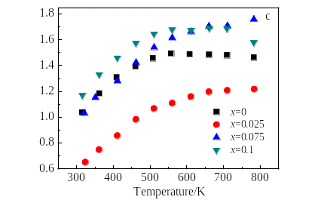
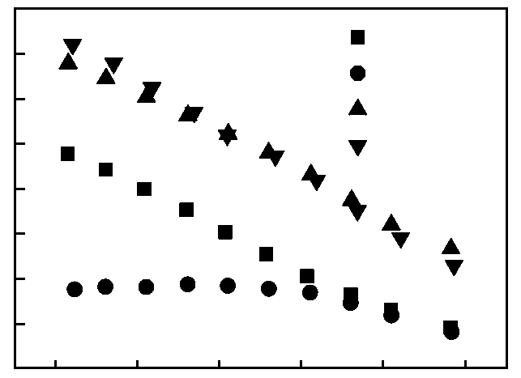
300 400 500 600 700 800

10
9
8
7
6
5
4
3
2

σ/×10⁴S·m⁻¹
x=0
x=0.025
x=0.075
x=0.1
a

α/×10⁻⁶V·K⁻¹

PF/mW·m⁻¹·K⁻²

Fig.2 Temperature dependences of electrical conductivity σ (a), Seebeck coefficient α (b) and power factor (PF) (c) for Mg_{2-x}Zn_{x}Si_{0.99}Sb_{0.01} (0 ≤ x ≤ 0.1) samples

κ using the Wiedemann-Franz relation, κ_{e} = L₀σT, The Lorenz number, L₀, on the basis of Fermi-Dirac statistics, is expressed as follows:
(1)
k
(2)
δ
(3)
k
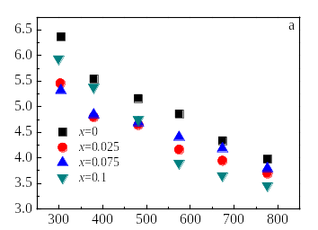
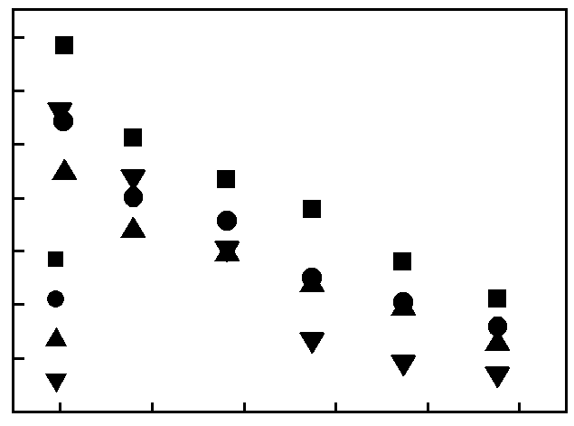
300 400 500 600 700 800
Temperature/K

6.0
5.5
5.0
4.5
4.0
3.5
3.0
2.5
x=0
x=0.025
x=0.075
x=0.1
d
L₀/×10⁻⁸V²·K⁻²
κ_{L}/W·m⁻¹·K⁻¹
η_{F}
κ/W·m⁻¹·K⁻¹

Fig.3 Temperature dependences of thermal conductivity κ (a),
reduced Fermi energy η_{F} (b), Lorenz number L₀ (c), and
lattice thermal conductivity κ_{L} (d) for Mg_{2-x}Zn_{x}Si_{0.99}Sb_{0.01}
(0 ≤ x ≤ 0.1) samples

where F_{i}(η_{i}) is the Fermi-Dirac integral, and η_{F} the reduced Fermi level, which was calculated from formula (3) and plotted in Fig.3b. The calculated Lorenz number L₀ (Fig.3c) increases with increasing of Zn content due to the reduced Seebeck coefficient. The lattice thermal conductivity decreases with increasing of Zn content at above 400 K due to the enhanced alloy scattering of short-wavelength phonons. At 300 K, the lattice thermal conductivity of the x= 0.075 sample is 4.7 W·m⁻¹·K⁻¹, ~20% lower than that of Mg₂Si_{0.99}Sb_{0.01}. The lowest lattice thermal conductivity of 2.86 W·m⁻¹·K⁻¹ is obtained at 770 K for the x = 0.1 sample.
Based on the measured electrical conductivity, Seebeck coefficient and thermal conductivity, the dimensionless TE figure of merit for the Mg_{2-x}Zn_{x}Si_{0.99}Sb_{0.01} (0 ≤ x ≤ 0.1) samples were calculated and plotted in Fig.4. ZT increases with increasing of temperature for all the samples. Due to enhanced electrical conductivity and reduced lattice thermal conductivity, the sample at x = 0.1 has the maximum ZT_{max} = 0.37 at 780 K, ~12% higher than that of the parent compound.

Fig.4 Temperature dependences of dimensionless TE figure of merit for the Mg_{2-x}Zn_{x}Si_{0.99}Sb_{0.01} (0 ≤ x≤ 0.1) samples

3 Conclusions
1) Single-phase Mg_{2-x}Zn_{x}Si_{0.99}Sb_{0.01} (0 ≤ x ≤ 0.1) solid solutions can be prepared by the B₂O₃ flux method combined with the SPS technique.
2) The Zn substitution leads to the reduction in Seebeck coefficient and lattice thermal conductivity. The electrical conductivity decreases upon Zn addition until x = 0.025 and then increases with increasing of the Zn content.
3) A ZT_{max} of 0.37 is obtained for Mg_{1.9}Zn_{0.1}Si_{0.99}Sb_{0.01} at 780 K, ~12% higher than that of Mg₂Si_{0.99}Sb_{0.01}.

References
- Vining C B, Rowe D M. CRC Handbook of Thermoelectrics [M]. Boca Raton: CRC Press, 1995
- Liu X H, Zhu T J, Wang H et al. Adv Energy Mater[J], 2013, 3: 1238
- Tani J, Kido H. J Alloy Compd[J], 2008, 466: 335
- Liu W, Tang X F, Sharp J. J Phys D: Appl Phys[J], 2010, 43: 085 406
- Zhang Q, Zhao X B, Yin H et al. J Alloy Compd[J], 2008, 464: 9
- Zaitsev V K, Fedorov M I, Gurieva E A et al. Phys Rev B[J], 2006, 74: 045 207
- Liu W, Tang X F, Li H et al. Chem Mater[J], 2011, 23: 5256
- Du Z L, Zhu T J, Chen Y et al. J Mater Chem[J], 2012, 22: 6838
- Zhang Q, He J, Zhu T J et al. Appl Phys Lett[J], 2008, 93: 102 109
- Du Z L, Zhu T J, Zhao X B. Mater Lett[J], 2012, 66: 76
- Gao H L, Zhu T J, Liu X X et al. J Mater Chem[J], 2011, 21: 5933
- Nolas G S, Wang D, Beekman M. Phys Rev B[J], 2007, 76: 235 204
- Kato A, Yagi T, Fukusako N. J Phys Condens Matter[J], 2009, 21: 205 801

Sb掺杂Mg_{2-x}Zn_{x}Si (0 ≤ x ≤ 0.1) 固溶体的热电性能

杜正良，崔教林
(宁波工程学院，浙江 宁波 315016)

摘 要：利用 B₂O₃ 助熔剂法结合 SPS 技术制备了Mg_{2-x}Zn_{x}Si_{0.99}Sb_{0.01} (0 ≤ x ≤0.1)固溶体。测量了300~780 K 温度区间内试样的电导率、塞贝克系数和热导率。发现晶格热导率随 Zn 取代量的增大而降低。而电导率随 Zn 取代量的增大而先降低后增大。讨论了影响电导率与晶格热导率的变化规律的具体内在机制。所有样品中 x = 0.075 样品的功率因子最高，在 780 K 达 1.76 mW·m⁻¹·K⁻²，比基体 Mg₂Si_{0.99}Sb_{0.01}高约 18%。x = 0.1 样品具有最低晶格热导率，在 770 K 达到 2.86 W·m⁻¹·K⁻¹。低晶格热导率使 Mg_{1.9}Zn_{0.1}Si_{0.99}Sb_{0.01} 具有最高热电优值，在780 K 达 0.37。
关键词：硅化镁；热电性能；热电材料；等电子取代

作者简介：杜正良，男，1984年生，博士，讲师，宁波工程学院，浙江 宁波 315016，电话：0574-87085770，E-mail: duzhengliang@126.com

