Hot deformation behavior and processing map of Ti-6Al-3Nb-2Zr-1Mo titanium alloy
Chen Haisheng^{1, 2}， Liu Xianghong^{1,2}， Liu Guangfa^{1,2}， Tang Xiaodong²， Luo Jinhua²，
Feng Yong^{1,2}，Li Jinshan¹，Fu Hengzhi ¹

¹ Northwestern Polytechnical University，Xi’an 710072，China; ² Western Superconducting Technologies Co., Ltd., Xi’an 710018, China

Abstract: The isothermal compression tests were performed over a range of temperatures 820-1060 ℃ and strain rates 0.001-1s⁻¹ on a Gleeble-3800 simulator. The constitutive equation of Ti-6Al-3Nb-2Zr-1Mo alloy is established to describe the changing rule of flow stress with the strain rate and deformation temperature. The apparent activation energies are calculated to be 764.71 kJ/mol in the dual phase region and 126.94 kJ/mol in the single phase region, respectively. The processing maps are constructed based on the dynamic material model (DMM) and the Prasad’s instability criterion at strains of 0.4 and 0.7, respectively. The maps exhibit a stable domain in the temperature range of 840-1060℃and strain rate range of 0.001-0.1 s⁻¹ with two peaks in power dissipation of 51%, occurring at 940 ℃/0.001 s⁻¹ and 880 ℃/1 s⁻¹, respectively. The high efficiency values of power dissipation indicate dynamic recrystallization/globalization in these fields. Based on the constructed processing maps, the optimal hot processing window of this alloy corresponds to the temperature range of 840-1060℃ and the low strain rate of 0.001-0.1 s⁻¹. The microstructure of specimens deformed at different conditions was analyzed and connected with the processing map. The material undergoes instability deformation at the strain rate of 1 s ⁻¹, which was predicted by the instability map.

Key words: Ti-6Al-3Nb-2Zr-1Mo alloy; hot deformation behavior; processing maps; microstructure

Titanium alloys have been widely used as light-weight high-temperature structural applications due to their excellent mechanical properties at high temperature, low density and high specific strength, and corrosion resistance^{[1,2]}. High temperature titanium alloys have been attracted to be made with components under a long-term load in the high temperature up to 600℃. In previous pioneering work, a number of titanium alloys regarding this kind performance have been studied concerning hot deformation behavior, microstructure evolution and processing parameters optimization, such as IMI834^{[3]}, IMI685^{[4]}, Ti60 alloy^{[5,6]} and Ti6242 alloy^{[7]}. In this study, Ti-6Al-3Nb-2Zr-1Mo alloy, which was a high temperature near-alpha titanium alloy developed in China, and it is mainly used for preparation of ship piping system because of the outstanding strength, weld-ability and corrosion resistance. So far, the increasing attention has been received with respect to Ti-6Al-3Nb-2Zr- 1Mo titanium alloy by many material scientists. In the previous studies, the efforts were mainly focused on microstructure, properties and application of this alloy. The effect of element addition ways on the microstructure and the performance of P/M Ti-6Al-3Nb-2Zr-1Mo was investigated by Huang et al^{[8]}, and came to the conclusion that much higher intensity and lower plasticity with the sintered alloy than the forged by means of the proper element addition ways. Wen et al^{[9]} studied the mechanical properties, microstructure and impact property of this alloy at five different annealing temperatures, and the best annealing schedule was obtained.
In general, the quality of a large structural part depends on the cogging, forging and following heat treat processes. Consequently, the forging quality of Ti-6Al-3Nb-2Zr-1Mo alloy essentially relies on its microstructure, which is highly associated with the hot working conditions of the titanium alloy^{[10]}, Unfortunately, little work has been conducted concerning hot deformation behavior for Ti-6Al-3Nb-2Zr- 1Mo titanium alloy. Therefore, it is necessary to carry out the present investigation. Thus the present work characterizes the hot deformation behavior of the Ti-6Al-3Nb-2Zr-1Mo titanium alloy based on experimental results in isothermal compression tests, the processing maps of this alloy are constructed in order to analyze the instability region and find out the optimum condition for plastic deformation procedure of the Ti-6Al-3Nb-2Zr-1Mo alloy.

Experiment
The starting microstructure as shown in Fig. 1 is typical duplex microstructure, which consisted of equiaxed, lamellar α and inter-granular β. The β-transus temperature for the alloy was measured to be approximately 995℃ by means of optical metallographic.
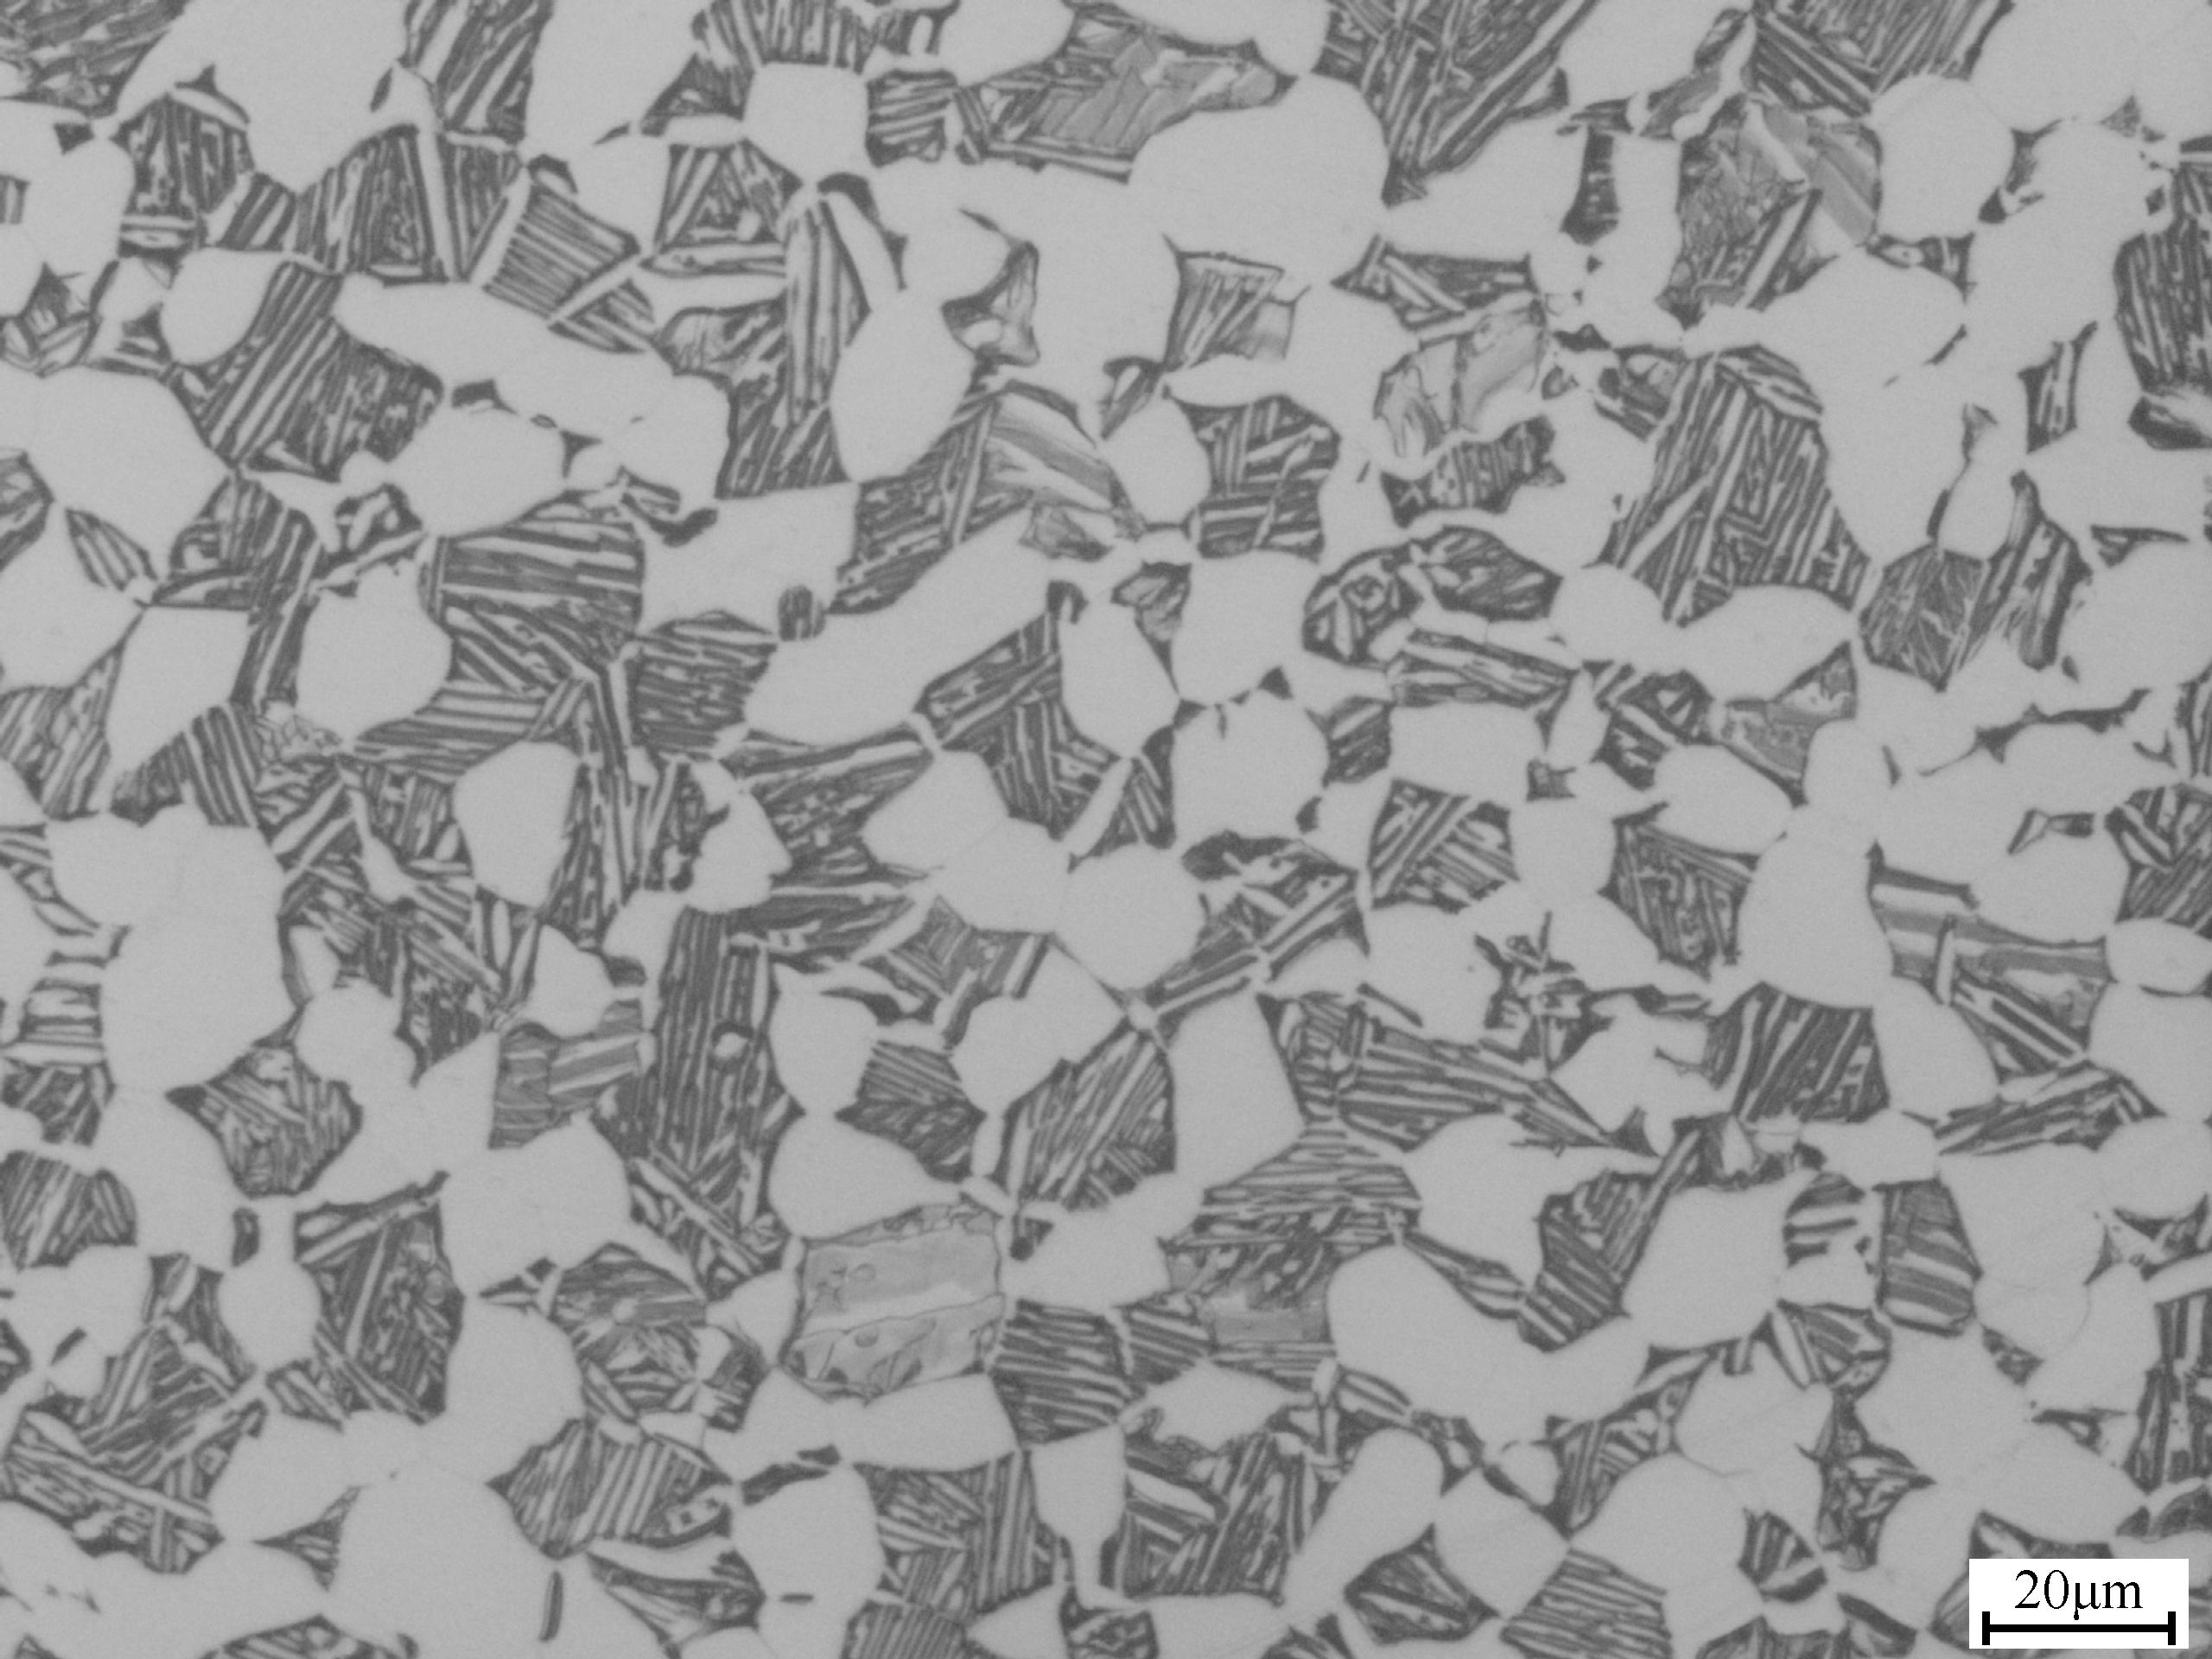
Fig. 1 The starting microstructure of the alloy
Compressive specimens with 8 mm in diameter and 12 mm in height were prepared from the Ti-6Al-3Nb-2Zr-1Mo alloy forged billet, then, hot compression tests were conducted by a Gleeble-3800 simulator. Concentric grooves with a depth of 0.1 mm were made on the top and bottom faces of the specimen to minimize the friction. Thermal couples were welded in the middle surface of the specimens to monitor the actual temperature of the specimen. Before starting isothermal compression, all specimens were heated at a rate of 15℃/s to the target temperature and held for 5 min to realize the homogenization of the temperature distribution. Subsequently, the compressed samples were quenched to room temperature immediately by water to preserve the microstructure during hot temperatures. Finally, the compressive specimens for microstructure observation were sectioned parallel to the compression direction, and the cut surface was prepared with standard methods. Metallographic observation was carried out on an Olympus-PMG3 optical microscope.
2 Results and Discussion
2.1 Hot deformation behavior
The dependence of flow stress on the strain for each compressing specimen under each testing condition was obtained after the isothermal compression tests. Typical flow stress–strain curves of Ti-6Al-3Nb-2Zr-1Mo alloy obtained at various strain rates (0.001, 0.01, 0.1 and 1 s⁻¹) and deformation temperature of 820 and 1000℃ with height reduction of 60% are shown in Fig. 2. The characteristics of the flow curves presented by the alloy at several strain rates and deformation temperatures can be markedly summarized as follows: In the α+β phase field (820℃, Fig. 2a), the flow stress curves exhibit flow softening behavior, and the higher strain rate more remarkable softening. However, in the single β phase field, the flow stress remains steady state as the true strain increases. From the aspects of softening mechanisms, such feature means that the rate of work hardening was quickly balanced by dynamic recrystallization or dynamic recovery ^{[11]}. Moreover, significant oscillation were observed in both the α+β dual phase and single β phase region, which indicated that flow localization, dynamic recrystallization and grain boundary cracking^{[12]}, the related characteristic has been studied by researchers in other titanium alloy^{[13,14]}.
2.2 Constitutive equation
During hot plastic deformation, it is widely recognized that the relationship between the steady-state flow stress, strain rate and deformation temperature is generally expressed in the form of hyperbolic sine relation^{[15,16]}:
(1)
Where A is the material constant for a certain strain, n is the tress exponent, Q is the apparent activation energy (kJ/mol) and R is the universal gas constant (kJ/(mol*K)). The stress exponent (n) and activation energy Q can be defined as follows:
(2)
(3)
In this study, the peak flow stress at different deformation temperatures and strain rates were used to constitutive parameters. According to the standard calculation procedures, the plot of ln[sinh(ασ)] versus 1/T is shown in Fig. 3. The apparent activation energy of the alloy is determined to be 764.71 and 126.94 kJ/mol for α+β phase and β single phase field, respectively. It can be seen from Fig. 4 that better linear fitting under the stress exponent 4.25 and 2.01 in the dual and single phase region, respectively. The activation energy of the alloy is 764.71 kJ/mol, which is much higher than that for self-diffusion of alpha titanium, i.e. 150 kJ/mol. It is well consistent with the findings in other near alpha titanium alloys ^{[5,6]}. Based on the experimental results, the constitutive equations that describe the flow stress as a function of the strain rate and deformation temperature for Ti-6Al-3Nb-2Zr- 1Mo alloy can be written as:
For α+β phase field,
For β phase field,

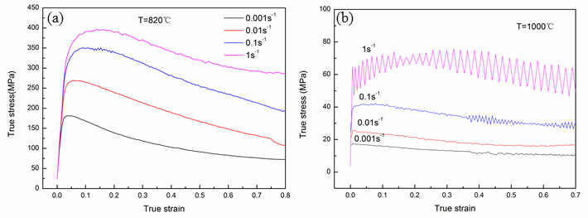
Fig. 2 The true stress–strain curves obtained from compression tests at deformation temperature: (a) 820℃; (b) 1000℃
Fig. 3 Relationship between peak flow stress and variations of different strain rates and temperatures in the dual phase region and single-phase region
Fig. 4 Relationship between peak flow stress and Zener–Hollomon parameter
2.3 Processing maps for Ti-6Al-3Nb-2Zr-1Mo alloy
The processing maps were always established to optimize hot deformation process on the basis of deformation mechanisms description and analysis during processing. The principle of this approach is the DMM which described in detail by Prasad ^{[17]}. Briefly, processing map is constructed by superimposing the instability map on the power dissipation map in the frame of temperature and strain rate at a certain strain, which can be successfully applied to divide the plastic deformation zone into safe and unsafe domain during plastic deformation. The efficiency of power dissipation (η), given by the strain rate sensitivity parameter (m) ^{[18]}:
(4)
Over this frame, the flow instability can be identified by means of superimposing a continuum instability criterion, and it can be used to severe plastic flow provided that it is established by extreme principles of irreversible thermodynamics as Ref. ^{[19]} and given by:
(5)
Where is to determine instability, is the strain rate. means metal flow into the instability area.
(a)
(b)
Fig. 5 The processing map of Ti-6Al-3Nb-2Zr-1Mo developed at true strain of 0.4 (a) and 0.7 (b)
To ascertain the suitable instability criterion for the Ti-6Al-3Nb-2Zr-1Mo alloy, the superimposed instability maps have been constructed based on the Prasad criteria at the strain of 0.4 and 0.7, respectively, which is shown in Fig. 5. It can be seen from the figure that most efficiency of power dissipation increases with the decreasing of strain rate and the increasing of strain, which has been reported by many researchers in other titanium alloy ^{[17]}. Besides, it can be clearly seen that two peak efficiency appear at the strain of 0.7: one occurring at about 940℃/0.001s⁻¹ with a peak efficiency of 51%; the other occurring at about 880℃/1s⁻¹ with a peak efficiency of 51%. According to the processing maps, the instability region always appears in the higher strain rates region (≥1s⁻¹), and the larger the strain the greater the instability area. The stable domain became narrower with the increasing strain, so the higher temperature and lower strain rate were requested to avoid the appearance of flow instability and realize the sound deformation at larger strain.
2.4 Stability domain
In general, high peak power dissipation efficiency is often associated with dynamic recrystallization or super-plasticity ^{[20]}. It means that the workability of Ti-6Al-3Nb-2Zr-1Mo alloy will be improved in the two regions. The efficiency of power dissipation for occurrence of super-plasticity is recognized as over 60%, whereas the efficiency associated with DRX is about 30-50%. It can be observed from Fig. 5 that the peak efficiency of power dissipation for the studied alloy is not higher than 55%. So super-plasticity can’t occur in these domains. In addition, the domains of the processing map could be interpreted on the basis of the efficiency variation characterization associated with the microstructural mechanisms. The metallograph of the alloy at different hot processing conditions of 940°C/0.001 s⁻¹ and 880°C/1 s⁻¹ are shown in Fig. 6. It is found that the values of efficiency of power dissipation in the two domains are about 51%, the dynamic recrystallization and global dynamic globalization occurred under these hot processing conditions. Compared with the original microstructure as shown in Fig. 1, it can be revealed that the recrystallized structure has taken the place of the original microstructure. Therefore, the microstructure observations provide obvious evidence that DRX (Fig. 6a) and globalization (Fig. 6b) are the predominant power dissipation mechanism. While relative low value of efficiency of power dissipation does not mean that the main mechanism of DRX cannot occur during hot deformation. The optimum hot processing regions for the DRX and globalization are located in the temperature range of 840-1000°C and strain rate range of 0.001-1 s⁻¹ with the peak efficiency of 51%.
2.5 Instability domain
Generally, flow instability mechanism is probably associated with bands of flow localization or cracking ^{[16]}. The instability domains mainly occur in the region of higher strain rate, and instability domains expand with the increase of strain. The instability map obtained corresponding to a strain of 0.7 on the basis of the Prasad instability criterion given by Eq. (5) is shown in Fig. 5(b), which is presented in the form of red domain. The presence of these instabilities in the microstructure of the component will have to be avoided by keeping away from the processing conditions of the unstable regimes. But such prediction ought to be further testified by the microstructure observation on the deformed specimens at corresponding hot processing conditions. The microstructure manifestation of instability regarding the present alloy is shown in Fig. 7, which corresponds to specimen deformed at 820°C/1 s⁻¹. The microstructure exhibits bands of flow localization which have been associated with local temperature rise at higher strain rates. This is because the fact that at higher strain rates, adiabatic deformation heat generated during hot working is conducted due to insufficient deforming time and low thermal conductivity of material. Thus, it is undesirable to obtain consistent mechanical properties and should be avoided during processing. Meanwhile, serrate oscillation of stress strain-curves above 0.1 s⁻¹ (Fig. 2) is possibly associated with flow instability as reported in Ref. ^{[17]}.
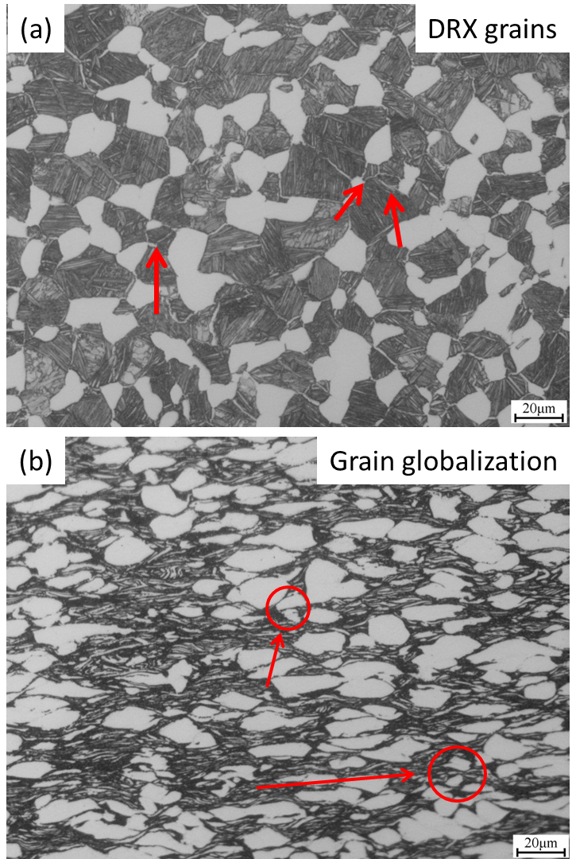
Fig. 6 Metallograph of Ti-6Al-3Nb-2Zr-1Mo alloy at different hot processing conditions: (a) 940°C/0.001 s⁻¹ and 880°C/1 s⁻¹
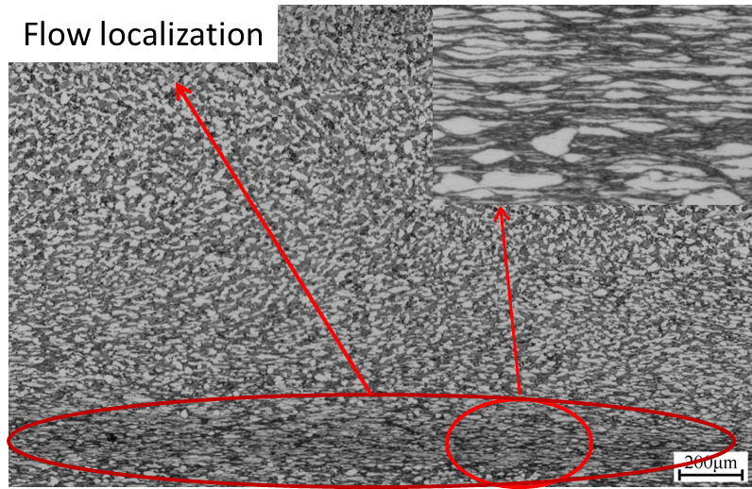
Fig. 7 Bands of flow localization observed at 820℃/1 s⁻¹ and 80% height reduction
3 Conclusions
1) The flow stress in the isothermal compression of Ti-6Al-3Nb-2Zr-1Mo alloy decreases with the increasing of deformation temperature and decreasing of strain rate. The constitutive equations for the alloy are developed using hyperbolic sine type equation in the dual phase region and single phase region, and the activation energy for deformation are calculated to be 764.714 and 126.936 kJ/mol, respectively.
2) The processing maps in the isothermal compression are constructed at the strains of 0.4 and 0.7. The stability domain occurs at low strain rate (<1s⁻¹) and the deformation temperature range of 840-1060℃ with two domains of peak efficiency of 51%: one occurring at 940℃/0.001 s⁻¹, the other occurring at 880℃/1 s⁻¹. However, at strain rate about 1 s⁻¹, the material undergoes flow instability manifesting as bands of flow localizations, which should be avoided in hot working of Ti-6Al-3Nb-2Zr-1Mo alloy.

References
- Williams J C, Starke E A. Acta Mater[J]. 2003, 51: 5775
- Ding X F, Lin J P, Zhang L Q et al. Acta Mater[J]. 2012, 60: 498
- Wang X, Jahazi M, Yue S. Materials Science and Engineering A [J], 2006, 434: 188
- Liu Y, Baker T N. Materials Science and Engineering A[J], 1995, 197:125
- Jia Weiju, Zeng Weidong, Liu Jianrong et al. Materials Science and Engineering A[J], 2011, 530:135
- Sun Feng, Li Jinshan, Kou Hongchao et al. Rare Metal Materials and Engineering[J], 2015, 44:848
- Prasad Y V R K, Gegel H L, Doraivelu S M et al. Metallurgical and Materials Transactions A[J], 1984, 15: 1883
- Huang Yu, Tang Huiping, Jia Wenpeng et al. Rare Metal Materials and Engineering[J], 2011, 40: 2227
- Wen Zhigang, Wang Weiqi, Wang Xiaoxiang et al. The Chinese Journal of Nonferrous Metals[J], 2010, 20:647
- Yeoma J T, Lee C S, Kima J H, et al., Materials Science and Engineering A[J], 2007, 449: 722–726
- Seshacharyulu T, Medeiros C S, Frazier W G et al. Materials Science and Engineering A[J], 2000, 284: 184
- Ankem S, Shyue J G, Vijayshankar M N, et al. Materials Science and Engineering A[J], 1989, 111: 51
- Li A B, Huang L J, Meng Q Y, Geng L, et al. Materials and Design[J], 2009, 30: 1625
- Seshacharyulu T, Medeiros S C, Frazier W G, et al. Materials Letter[J], 2001, 47: 133
- McQueen H J, Ryan N D. Materials Science and Engineering A[J], 2002, 322: 43
- Sellars C M, McTegart W J. Acta Metallurgica[J], 1966, 14: 1136
- Prasad Y V R K, Gegel H L, Doraivelu S M et al. Metallurgical and Materials Transaction A[J], 1984, 15(10): 1883
- Srinivasan N, Prasad Y V R K, Rama Rao P. Materials Science and Engineering A[J], 2008, 476: 146
- Sneddon I N, Hill R et al. Progress in Solid Mechanics[M], Amsterdam: North-Holland Publishing, 1965:91
- Poletti C, Degischer H P, Kremmer S, W. Marketz. Materials Science and Engineering A[J], 1998, 486: 127

Ti-6Al-3Nb-2Zr-1Mo钛合金热变形行为及加工图

陈海生^{1,2}，刘向宏^{1,2}，刘广发^{1,2}，唐晓东²，罗锦华²，冯 勇^{1,2}，李金山¹，傅恒志¹
(1. 西北工业大学，陕西 西安 710072)
(2. 西部超导材料科技股份有限公司，陕西 西安 710018)

摘 要：利用Gleeble-3800热模拟试验机，在变形温度为820-1060℃及应变速率为0.001-1s⁻¹参数范围内对Ti-6Al-3Nb-2Zr-1Mo钛合金进行等温恒应变速率压缩试验。建立了该合金的高温变形本构方程，得到两相区和单相区的表面激活能分别为764.714 和126.936 kJ/mol。基于DMM和Prasad失稳准则建立了应变为0.4和0.7时的热加工图。分析加工图发现: Ti-6Al-3Nb-2Zr-1Mo钛合金在840-1060℃，应变速率为0.001-0.1s⁻¹,之间主要发生DRV/DRX，此区间变形时耗散率峰值51%分别出现在940℃/0.001s⁻¹和880℃/1s⁻¹，其变形后微观组织演变机制与热加工图匹配较好，当变形发生在820℃，较高应变速率（≥1s⁻¹）下该合金加工时易发生流变失稳现象。
关键词：Ti-6Al-3Nb-2Zr-1Mo钛合金；本构方程；加工图；微观组织

作者简介：陈海生，男，1980年生，博士生，西北工业大学材料学院，陕西 西安710072，电话：029-86514523，E-mail: chenhsh15@163.com

