
Effect of Monofunctional Monomers on Rheological and Photosensitive Properties of Resin-Based Alumina Slurry for Stereolithograph
Hu Chuanqi, Chen Yufeng, Huang Xiaoting, Liu Hailin, Gang Boren, Jia Zhihui, Huo Yanli, Yang Taisheng, Wang Hua, Li Hui, Sun Haoran

China Building Materials Academy Co., Ltd, Beijing 100024, China

Abstract: The effect of monofunctional monomers on the rheological and photosensitive properties of resin-based Al₂O₃ slurry was studied from the perspective of molecular structure and functional groups. The bifunctional group monomer 1,6-hexanediol diacrylate (HDDA) and triple functional group monomer trimethylolpropane triacrylate (TMPTA) were used as raw materials, adding monofunctional monomers X with a selected volume ratio of V_{HDDA}:V_{X}:V_{TMPTA}=6:3:1. The photosensitive resin was fabricated by magnetically stirring at room temperature (RT), and the rheological properties of monofunctional monomers X and resins were studied. The resin-based alumina slurries with solid content of 30vol%~50vol% were prepared by ball milling, the 3D printing process based on stereolithography (SL) was realized and the alumina bodies were fabricated. The monofunctional monomers acryloylmorpholin (ACMO), 2-phenoxyethyl acrylate (2-PHEA), and hydroxyethyl acrylate (HEA) with hydrophilic groups and high photopolymerization activity were used, and the resins with high activity and photopolymerization accuracy were fabricated, benefiting for fabricating Al₂O₃ slurries with superior rheological and photosensitive properties.

Key words: monofunctional monomers; resin-based alumina slurry; rheological properties; photopolymerization properties; stereolithography

Stereolithography (SL) is an attractive additive manufacturing (AM) technique used for ceramic 3D printing, because of its ability for fabricating complex-shaped ceramic parts with high dimensional accuracy and high surface quality at both fine resolution and micrometer scale, which is superior than other AM techniques, such as direct ink writing (DIW)^{[1]}, fused deposition modeling (FDM), etc^{[2]}.
The SL technique is usually based on the photopolymerization of photosensitive resin-based ceramic slurry which consists of ceramic particles, photosensitive resin, and additive, such as dispersant, photo initiator, etc. It is a process that the ultraviolet light (UV) is used to selectively cure a liquid surface, the light activates the polymerization process of photo-polymerizable monomers, a crosslinked polymer network forms, in which the ceramic particles are embedded, and finally the ceramic green body with 3D structure by curing layer-by-layer forms^{[2,3]}. The SL technique is widely used for preparing Al₂O₃^{[4]}, ZrO₂^{[5,6]}, SiO₂^{[7]}, SiC^{[8,9]} and ZrO₂- Al₂O₃^{[10,11]} composite ceramic parts in recent years.
The photosensitive resin-based ceramic slurry is crucial for fabricating complex ceramic parts with high dimensional accuracy by SL technique. It always requires high solid content, high photopolymerization activity and superior rheological behavior^{[3]} including the suitable viscosity. The influence factors of rheological and photosensitive properties of slurry were studied systematically by researchers, such as ceramic powder characteristics (specific surface area, particle size and distribution), particle morphology^{[12]}, the surface modification of the powder^{[13,14]}, and additives^{[15,16]}. Ref. [17] discussed the synthesis and properties of photosensitive resin with high curing precision, but it was not aimed at the photosensitive resin-based ceramic slurry. The resins always show the characteristics of high viscosity and poor hydrophilicity, which are not suitable for fabricating ceramic slurry with high solid content and photosensitive properties. Therefore, the suitable resins for preparing ceramic slurries with superior rheological and photosensitive properties were fabricated and the effect of photo polymerizable monomers on the rheological and photosensitive properties of the resin-based alumina slurry was investigated.
The photosensitive resins usually contain several kinds of monomers with low viscosity and high photopolymerization activity. The monomers are small organic molecules with polymerizable functional groups, which not only have the function of diluting and adjusting the viscosity of the slurry, but also participate in the photopolymerization process, affecting the rheological property and the photopolymerization activity of the slurry obviously, the final dimension precision, and the strength and surface quality of polymerized ceramic green bodies^{[18]}. So the monomers play an important role in preparing ceramic slurries for SL.
According to the literature^{[13,14,18]}, the bifunctional group monomer 1,6-hexanediol diacrylate (HDDA) and triple functional group monomer trimethylolpropane triacrylate (TMPTA) are superior monomers because of their low viscosity, high dilution ability and high reaction activity. The resins with a selected volume ratio of V_{HDDA}:V_{X}:V_{TMPTA}=6:3:1 (X represents various monofunctional monomers)^{[13,14]} were fabricated. The rheological properties of monofunctional monomers and resins were studied. The resin-based alumina slurries with solid content of 30vol%~50vol% by mechanical milling at room temperature (RT) were fabricated, and the 3D printing based on stereolithography was realized by the photo curing 3D printer. The difference of rheological and photopolymerization properties caused by different monofunctional monomers was investigated and discussed from the perspective of the molecular structure and functional groups points.

1 Experiment
The monomers and photo initiator used in this research are listed in Table 1 and Table 2^{[18]}. Adding 3.0wt% bis (2, 4, 6-trimethylbenzoyl) phenyl phosphine oxide (BAPO) as the photo initiator, the resins were fabricated with the selected volume ratio of V_{HDDA}:V_{X}:V_{TMPTA}=6:3:1 (X represents various monofunctional monomers) by magnetically stirring at RT for 20 min. The slurries were fabricated by ball milling at RT in the nylon ball mill tank, containing resins, 3.0wt% α-Al₂O₃ powder (produced by Magnesium Aluminum Company with median diameter of D₅₀=0.60 μm) and dispersant alkyl acrylate phosphate (PM1590, produced by Guangzhou Jingde Chemical Materials Co., Ltd). Zirconia balls were used as the milling medium. The rheological property was tested by NXS-11A rotary viscometer from Chengdu Instrument Factory, and the photopolymerization process of resins and slurries was realized by NOVA 3D-L101A intelligent photo curing 3D printer from Shenzhen Nova Intelligent Technology Co., Ltd. During the 3D printing process, the thickness of each layer was set as 0.025 mm. In order to make sure the cured layers well attach to the substrate, 6 layers were produced at the beginning with the exposure time of 150 s per layer, and then the exposure time of the following layer decreased to100 s.
2 Results and Discussion
2.1 Rheological properties of monofunctional monomers
The monofunctional monomer^{[18]} contains only one active group in each molecule to participate in the photopolymerization process. It has low molecular mass, low viscosity, strong dilution ability, and high conversion efficiency. The monofunctional monomers are usually classified as alkyl acrylate, (methyl)-hydroxyl acrylate, (methyl)-acrylate with ring or benzene ring structure, (methyl)-acrylate and vinyl active monomer. The rheological properties of the first three kinds of monomers are listed in Table 3.
Fig.1 shows the viscosity-shear rate curves, and it can be seen that the monomers have very low viscosity, and the viscosity value do not change with the shear rate, indicating that they are Newtonian fluid. For Newtonian fluids, the viscosity mainly relates to the temperature and material properties. Combining the viscosity of monofunctional monomers and the molecular structure, it can be observed that the viscosity values of (methyl)-acrylate monomers with ring structure or benzene ring structure are much higher than those of (methyl)-hydroxyethyl acrylate and alkyl acrylate monomers, for instance, the viscosity value of CTFA, ACMO, IBOMA and 2-PHEA is much higher than that of HEA, 2-EHA, and BA. However, the alkyl acrylate monomer LA is a exception, because it has a much higher molecular mass due to the long hydrophobic aliphatic main chains [CH₂]₁₁.
Fig.1 Shear rate-viscosity curves of monofunctional monomers

It can be seen that the (methyl)-acrylate monomers with ring structure or benzene ring structure have much more complicated molecular structure and higher molecular mass than (methyl)-hydroxyethyl acrylate and the alkyl acrylate monomers do. So the viscosity of (methyl)-acrylate monomer with ring or benzene ring structure is the highest among the monofunctional monomers. Therefore, it can be concluded that for monofunctional monomers, the viscosity values mainly relate to the molecular structure and molecular mass.

Table 1 Parameters of monofunctional photo-polymerizable monomers
Type | Monomer | Abbr. | Molecular structure | Molecular  mass/g∙mol⁻¹ | Density/  g∙cm⁻³
Alkyl acrylate | Butyl acrylate | BA |  | 128 | 0.8934
Alkyl acrylate | Isooctyl acrylate | 2-EHA |  | 184 | 0.881
Alkyl acrylate | Lauryl acrylateLA | LA |  | 240 | 0.884
Alkyl acrylate | Ethoxyethoxyethyl acrylate | EOEOEA |  | 188 | 0.995
Hydroxyl acrylate/  hydroxyl methacrylate | Hydroxyethyl acrylate | HEA |  | 116 | 1.1038
Hydroxyl acrylate/  hydroxyl methacrylate | Hydroxyethyl methacrylate | HEMA |  | 130 | 1.072
Acrylate/methacrylate  with ring structure or  benzene ring structure | Glycidyl methacrylate | GMA |  | 142 | 1.073
 | Isobornyl methacrylate | IBOMA |  | 222 | 0.980
 | Tetrahydrofuran  methyl acrylate | THFA |  | 156 | 1.048
 | 2-phenoxyethyl acrylate | 2-PHEA |  | 192 | 1.100
 | Cyclotrimethylolpropane  methyl acetal acrylate | CTFA |  | 200 | 1.100
Acrylamide | Acryloylmorpholin | ACMO |  | 192 | 1.140

Table 2 Parameters of bifunctional and trifunctional group photo-polymerizable monomers and photo initiator
Monomer | Abbr. | Molecular structure | Molecular mass /g∙mol⁻¹ | Density /g∙cm⁻³
1,6-hexanediol diacrylate | HDDA |  | 226 | 1.030
Trimethylolpropane triacrylate | TMPTA |  | 296 | 1.110
Bis (2,4,6-trimethylbenzoyl)  phenyl phosphine oxide | BAPO |  | 418 | 1.230~1.250

2.2 Rheological properties of photosensitive resins
Obtaining high activity photosensitive resin with low viscosity is the precondition of preparing high activity photosensitive resin-based ceramic slurries with high solid content and low viscosity. Bifunctional group monomers^{[18]} contains two active groups in each molecule to participate in the photopolymerization process, so the reaction rate is much higher than that of monofunctional monomers. The viscosity value increases because of the higher molecular mass and complicated molecular structure. Trifunctional group monomers^{[18]} contains three active groups in each molecule, so their photopolymerization rate, cross-linking density and hardness of cured body are much higher than those of the monofunctional and bifunctional monomers after photopolymerization, and their viscosity is much higher due to their higher molecular mass and more complicated molecular structure.
HDDA and TMPTA are superior monomers because of their low viscosity, high dilution ability, and high reaction activity. Both of them are Newtonian fluid, and their viscosity value at room temperature is 5.9 and 83.0 mPa∙s, respectively. The corresponding resin composites with a selected volume rate of V_{HDDA}:V_{X}:V_{TMPTA}=6:3:1 were fabricated, and their rheological properties were studied, as shown in Table 3 and Fig.2.
Table 3 shows that the resin containing CTFA has the highest viscosity of 14.0 mPa∙s, and the resin contains BA has the lowest viscosity of 5.0 mPa∙s. Fig.2 shows that the resins have very low viscosity and excellent fluidity, and they viscosity values do not change with the shear rate. So they are also Newtonian fluid. The order of viscosity values of the resins with different monofunctional monomers is: CTFA>ACMO>2-PHEA>IBOMA>LA=HEMA>THFA>EOEOEA>GMA>HEA>2-EHA>BA. The monofunctional monomers affect the rheological properties of resins to some extent due to their molecular structure and functional groups.

Table 3 Viscosity of monofunctional monomers X and corresponding resin composites at ~20 °C (mPa∙s)
X | Monofunctional monomer | Corresponding resin composite
CTFA | 20.0 | 14.0
ACMO | 14.5 | 13.2
IBOMA | 12.2 | 10.2
2-PHEA | 9.2 | 12.2
LA | 5.5 | 9.1
HEA | 5.5 | 6.6
HEMA | 5.5 | 9.1
THFA | 3.8 | 8.0
EOEOEA | 3.8 | 7.6
GMA | 2.8 | 6.7
2-EHA | 2.0 | 6.3
BA | 1.5 | 5.0

The viscosity values of the resins basically vary with the viscosity values of the containing monofunctional monomers, but HEA is an exception. The viscosity value of HEA is in the sixth place among that of those monofunctional monomers, but the viscosity value of corresponding resin decreases obviously down to the tenth place, indicating that HEA has better dilution performance and it mainly relates to the hydroxyl groups -OH, which is beneficial to the preparation of resin-based ceramic slurry with low viscosity and high solid content. But this law is not suitable for HEMA. Though there is hydroxyl groups -OH in its molecular structure, the viscosity of the corresponding resin does not decrease as exception, because the functional group -CH₃ weakens its diluting ability in some degree.
Fig.2 Viscosity-shear rate curves of photosensitive resins with different monofunctional monomers

2.3 Rheological property of Al₂O₃ slurries
In order to compare the effect of monofunctional monomers X on the rheological properties of photosensitive resin-based Al₂O₃ slurries, the Al₂O₃ slurries with the solid content of 30vol% were prepared at the volume ratio of V_{HDDA}:V_{X}:V_{TMPTA}=6:3:1. Table 4 shows the viscosity values of the slurries under the shear rate of 27.67 s⁻¹ at room temperature. Fig.3 shows the viscosity-shear rate curves, and it can be seen that the viscosity are below 300.0 mPa∙s and the slurries have good fluidity.

Fig.3 Viscosity-shear rate curves of different slurries with solid content of 30vol%

Compared with Fig.2 and 3, the viscosity values of slurries do not vary with the viscosity of resins, especially when X=LA, IBOMA, BA, 2-EHA and THFA. The viscosity of these resins are much lower than that of other resins, but the viscosity of corresponding slurries with solid content of 30vol% increases rapidly, which mainly relates to the molecular structure and functional groups of monomers X.
For monofunctional monomer LA, it has long hydrophobic aliphatic main chains [CH₂]₁₁, and the viscosity increases significantly. For IBOMA and THFA, they have benzene ring structure which has strong hydrophobicity and cannot wet the ceramic powder easily during the fabrication of ceramic slurry. It is the same mechanism for alkyl acrylate monomers BA and 2-EHA: they have strong hydrophobicity and cannot wet the ceramic powder throughly.
When the X=2-PHEA, CTFA, ACMO, EOEOEA, HEMA, HEA and GMA , the viscosity of slurries decreases, indicating that these monomers have strong hydrophilicity. For example, HEA has hydroxyl group -OH, and 2-PHEA has hydrophilic benzene ring structure. So they can wet the hydrophilic ceramic powders better and form a stable dispersion.
Fig.4 shows the viscosity of slurries with different solid contents under the shear rate of 27.67 s⁻¹. It can be seen that when the solid content is below 45vol%, the viscosity od slurries is under 750 mPa∙s and shows good fluidity; when the solid content reaches 50vol%, the viscosity of the slurry rises sharply.
2.4 Photopolymerization property of Al₂O₃ slurries
The fluidity and viscosity of slurries mainly rely on the hydrophilicity of monomers X, which is defined by the molecular structure and functional groups. Some of those monomers have strong hydrophobicity and cannot wet the Al₂O₃ powder well, so the viscosity of slurries are much higher, even shows no fluidity, increasing the difficulty of photopolymerization process.
In order to better evaluate the effect of monomers X on the photopolymerization property of Al₂O₃ slurries systematically, the slurries with a lower solid content of 30vol% was fabricated, i.e., the viscosity of slurries is lower, and the fluidity is higher. The designed printing dimension on Z-axis direction is 3.00 mm. The thicknesses of cured bodies are listed in Table 4.
76.0
146.0
246.0
724.0
1732.0

Fig.4 Viscosity of slurries with solid content from 30vol%~50vol% under the shear rate of 27.67 s⁻¹
Fig.5 shows the appearance of resin with the composition of V_{HDDA}:V_{HEA}:V_{TMPTA}=6:3:1 after photopolymerization process (Fig.5a), and the Al₂O₃ strip samples made by resin-based Al₂O₃ slurries with solid content of 30vol% through SL technique (Fig.5b). It shows that the resin has high photopolymerization accuracy. Fig.6 is schematic diagram of the UV light transfer through the slurry. Al₂O₃ particles are regarded as sphere for simplicity. When the UV light is focused on the slurry, a part of the in-put light is absorbed by the particles, and the out-put light is much smaller than in-put light. In order to trigger the polymerization process and form a strong crosslinked polymer network, the resin must be robust and active, which depends on the monomers.

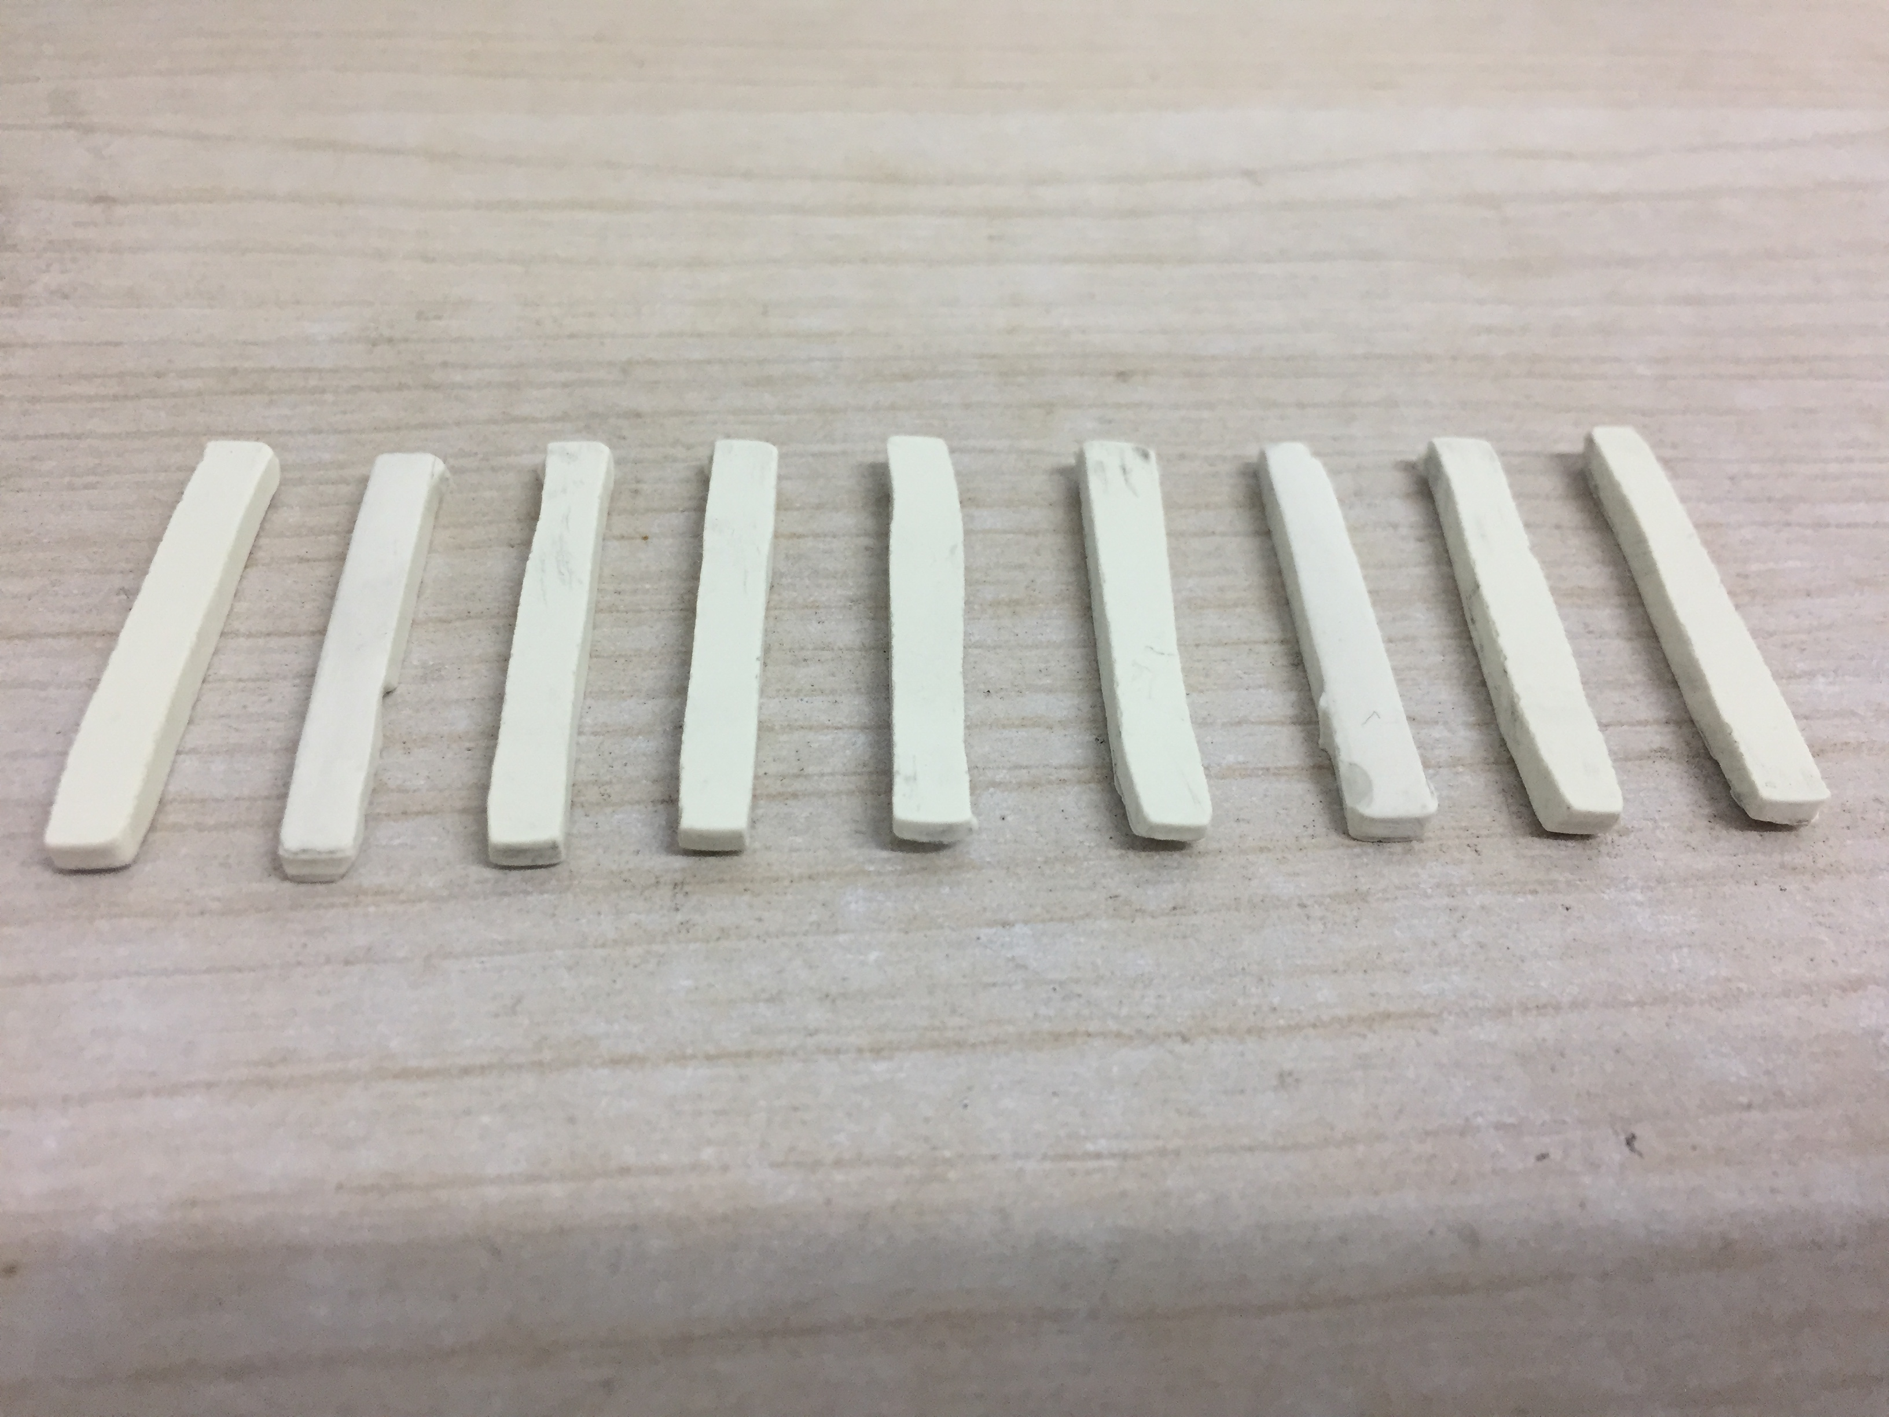
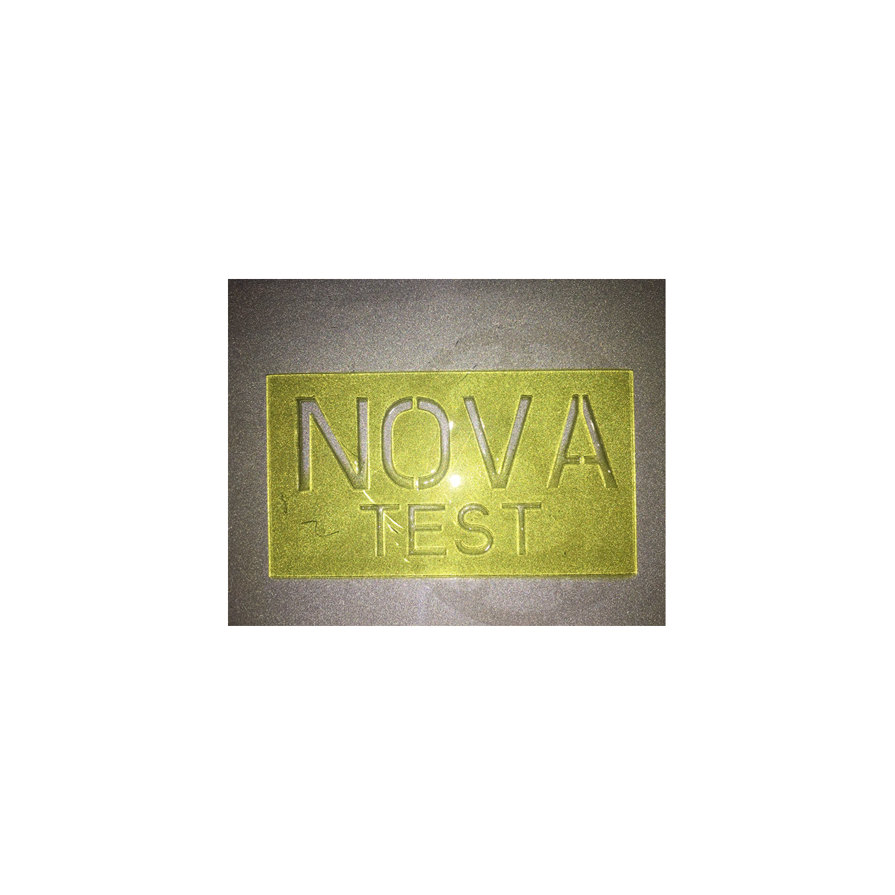
5 mm
b
10 mm
a

Fig.5 Cured photosensitive resin (a) and Al₂O₃ strip samples made by slurries with solid content of 30vol% by SL technique (b)

The ability of continuous printing is critical for slurries for SL technique, which mainly refers to the bonding strength between the slurry and the substrate at the beginning of the photopolymerization process, and the adhesion strength between the cured layers. The bonding strength largely relates to the molecular functional groups of the monomers X in slurries.
During the 3D printing process of SL technique, if the mentioned strength is not strong enough, the layer may separate from the substrate or previous layers and interrupt the photopolymerization process due to the viscous force of slurries and the increasing gravity of curing body.
The slurries in this research have good rheological properties and high photopolymerization activity when X=ACMO, HEA and 2-PHEA. The continuous photopolymerization on the substrate of aluminum alloy is realized, and the thickness of cured ceramic bodies is over 3.00 mm, indicating that volume expansion occurs in the Z-axis direction, and the linear expansion rate of slurries with ACMO, HEA and 2-PHEA is 28.0%, 20.0% and 6.7%, respectively.

In-put
UV light
Polymer network
Out-put
Al₂O₃ particle

Fig.6 Schematic diagram of UV light transfer through slurries

Monomer ACMO is an acrylamide monomer with high reaction activity, and its speed of photopolymerization is 2~3 times faster than that of other monofunctional monomers^{[18]}. So it can be well attached to the aluminum alloy substrate at the beginning and make sure the adhesion between layers is strong. Monomer HEA contains hydroxyl group -OH, so it is beneficial to improving its adhesion with polar materials and the bonding strength between layers, resulting in a better attachment to the aluminum alloy substrate at the beginning and a strong adhesion between layers. Therefore, the continuous printing can be realized. Monomer 2-PHEA has the benzene ring structure, which benefits for improving the adhesion between the slurry and cured layers.

Table 4 Viscosity of Al₂O₃ slurries and thickness of cured bodies
X | Viscosity of slurries/mPa∙s  (under shear rate of 27.67 s⁻¹) | Thickness of cured bodies/mm
IBOMA | 286.0 | 1.38
2-EHA | 216.0 | 0.10
THFA | 120.0 | 2.20
2-PHEA | 118.0 | 3.20
LA | 102.0 | 3.04
BA | 96.0 | 2.70
CTFA | 94.0 | 2.00
HEMA | 94.0 | 0.40
ACMO | 84.0 | 3.84
EOEOEA | 82.0 | 2.48
HEA | 68.0 | 3.60
GMA | 56.0 | 1.60

When the monomer X=LA, BA, EOEOEA, CTFA, GMA, IBOMA, HEMA and 2-EHA, the cured ceramic bodies are separated easily from the substrate and the previous cured layers due to the weak bonding strength, resulting in the interruption of photopolymerization finally, because the monomers have unsuitable functional groups to ensure the bonding strength with the aluminum alloy substrate and the adhesion between layers.
3 Conclusions
1) The resin consisting of 1,6-hexanediol diacrylate (HDDA), trimethylolpropane triacrylate (TMPTA) and different monomers can be fabricated. The viscosity of resins with volume ratio of V_{HDDA}:V_{X}:V_{TMPTA}=6:3:1 mainly varies with the viscosity of monofunctional monomers X. But the resin containing hydroxyethyl acrylate (HEA) is an exception, because of the hydroxyl group -OH in its molecular structure.
2) Monomers 2-phenoxyethyl acrylate (2-PHEA), cyclotrimethylolpropane methyl acetal acrylate (CTFA), acryloylmorpholin (ACMO), ethoxyethoxyethyl acrylate (EOEOEA), hydroxyethyl methacrylate (HEMA), HEA, and glycidyl methacrylate (GMA) have hydrophilic groups, which benefits for fabricating Al₂O₃ slurries with superior rheological properties.
3) The Al₂O₃ slurries have different photopolymerization thicknesses due to different functional groups of monofunctional monomers. When the Al₂O₃ slurries contain ACMO, 2-PHEA, and HEA, the continuous printing by photopolymerization can be better realized.

References
- Li Yayun, Li Bo, Li Longtu et al. Rare Metal Materials and Engineering[J], 2015, S1(44): 81 (in Chinese)
- Zocca A, Colombo P, Gomes C M, et al. Gomes. Journal of the American Ceramic Society[J], 2015, 98(7): 1983
- Chen Zhangwei, Li Ziyong, Li Junjie et al. Journal of the European Ceramic Society[J], 2019, 39(4): 661
- Zhang Keqiang, Xie Chen, Wang Gang et al. Ceramics International[J], 2019, 45(1): 203
- He Rongxuan, Liu Wei, Wu Ziwei et al. Ceramics International[J], 2018, 44(3): 3412
- Zhang Keqiang, He Rujie, Ding Guojiao et al. Materials Science and Engineering A[J], 2020, 774: 138 768
- Bae C J, Kim D, Halloran J W. J. Eur. Ceram. Soc.[J], 2019, 39(2-3): 618
- Ding Guojiao, He Rujie, Zhang Keqiang et al. Ceramics International[J], 2020, 46(11): 18 785
- Chen Jiangshan, Wang Yuanjie, Pei Xueliang et al. Ceramics International[J], 2020, 46(9): 13 066
- Borlaf M, Szubra N, Serra-Capdevila A et al. Journal of the European Ceramic Society[J], 2020, 40(4): 1574
- Liu Xiaoyan, Zou Bin, Xing Hongyu et al. Ceramics International[J], 2020, 46(1): 937
- Chen Zhangwei, Li Junjie, Liu Chengbo et al. Ceramics International[J], 2019, 45(9): 11 549
- Zhang Shuai, Sha Na, Zhao Zhe. Journal of the European Ceramic Society[J], 2017, 37(4): 1607
- Li Kehang, Zhao Zhe. Ceramics International[J], 2017, 43(6): 4761
- Adake C V, Bhargava P, Gandhi P. Ceramics International[J], 2015, 41(4): 5301
- Xing Zhanwen, Liu Weiwei, Chen Yao et al. Ceramics International[J], 2018, 44(16): 19 939
- Biwu Huang, Baolin Wu, Linlin Han et al. Journal of Wuhan University of Technology, Materials Science[J], 2019, 34(4): 761
- Jin Yangzhi. Handbook on Properties and Applications of Light Curing Materials[M]. Beijing: Chemical Industry Press, 2015: 6 (in Chinese)

单官能团单体对光固化成型用树脂基氧化铝浆料流变性和光敏性能的影响

胡传奇，陈玉峰，黄小婷，刘海林，冮博仁，贾志辉，霍艳丽，杨泰生，王 华，李 荟，孙浩然
(中国建筑材料科学研究总院有限公司，北京 100024)

摘 要：从分子结构和官能团的角度研究了单官能团单体对光敏树脂基氧化铝浆料流变性能和光固化性能的影响。以双官能团单体1,6-己二醇二丙烯酸酯（HDDA）和三官能团单体三羟甲基丙烷三丙烯酸酯（TMPTA）为原料，按照HDDA:X:TMPTA=6:3:1的体积比加入单官能团单体X，通过室温磁力搅拌制备出光敏树脂，研究了单官能团单体X和树脂的流变性能。采用机械球磨法制备了30%~50%（体积分数）固相含量的光敏树脂基氧化铝浆料，实现了基于立体光刻（SL）技术的3D打印并制备出了氧化铝坯体。本研究确定了3种具有亲水性和高光固化活性的单官能团单体，即丙烯酰吗啉（ACMO）、丙烯酸2-苯氧乙酯（2-PHEA）和丙烯酸羟乙酯（HEA），优化了光敏树脂，使其具有高活性和高固化精度，可用于制备流变性和光固化性能优异的氧化铝浆料。
关键词：单官能团单体；树脂基氧化铝浆料；流变性能；光敏性能；光固化成型

作者简介：胡传奇，男，1986年生，博士生，高级工程师，中国建筑材料科学研究总院有限公司，北京 100024，电话：010-51167534，E-mail: huchuanqi08@163.com

